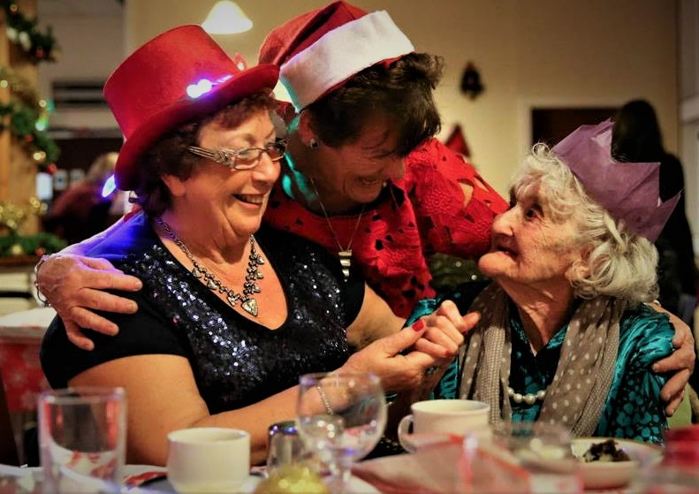

Annual Report

2018-2019

·: . . because above all we need good friends "

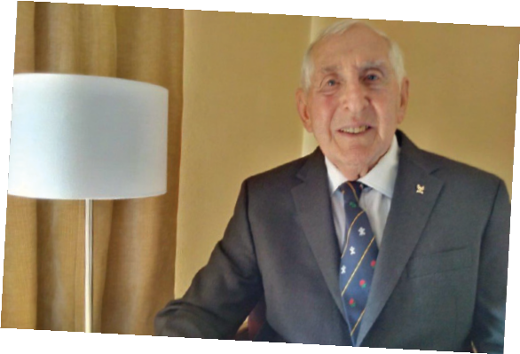
A MESSAGE FROM
OUR AMBASSADOR

Dear Friends

I write as Ambassador for Friends of the Elderly to thank all our individual and corporate donors and each of our volunteers for their generous support and commitment to the task of alleviating loneliness and isolation among the elderly who are alone.
The increasing pace of change raises many new challenges for us all – especially for many in their senior years. The stability that marked local communities a generation or two ago has been all but lost. Where once long established and supportive neighbourly togetherness was the norm – now change seems to have become the order of the day. While new communications technologies offer extraordinary possibilities - the elderly suffer from the increasing loss of the face-to-face social contacts that so enriched daily life in their early years.
For close on forty years Friends of the Elderly Ireland has continued to bring one-to-one friendship and social togetherness to hundreds of elderly men and women who would otherwise be desperately alone. Through the generosity of our loyal donors, the devotion of our volunteers and the skilful dedication of our small staff our Community of Friends continues to flourish.
My heartfelt thanks to you all

Honorary Ambassador - Dr Ronnie Delany
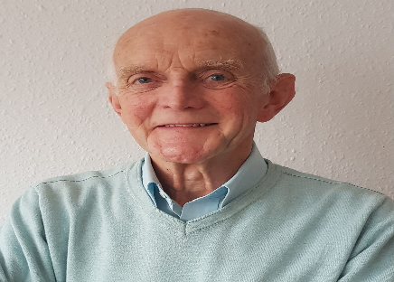
A MESSAGE FROM OUR CHAIRPERSON
Loneliness is a widespread and ever increasing fact of life in our society. While it touches all age groups to some extent the elderly who live alone are particularly affected by it. Imagine Croke Park on All Ireland Final day – with an attendance of at least 80,000. This is the number of persons aged 75 or more who now live alone in Ireland. While many of these are fortunate to have family and friends close by - almost half of them (36.000) - suffer from loneliness and social isolation. Three quarters of these are women. With increasing age most individuals find that their mobility is reduced - sometimes quite quickly. And in relatively few years many can lose life-long friends and kind neighbours and see their sons and daughters and grandchildren scattered through relocation in Ireland or through emigration. Almost inevitably their self-confidence falters and the capacity to reach out to make new acquaintances and friends is much diminished or even lost entirely. Social isolation and extreme loneliness can so easily follow. For almost forty years Friends of the Elderly Ireland have been reaching out through a handful of dedicated staff and hundreds of volunteers to bring one-to-one friendship and social engagement to hundreds of the most isolated and lonely elderly in our society. Friends of the Elderly Ireland
- believes in the unique worth of every individual
- advocates for mutual respect and for the dignity of all
- respects each individual’s choices and promotes independent living
- celebrates positive and active ageing.
Thanks to the continuing support of our generous donors and the dedication of our volunteers we continue to bring a heart-warming togetherness to hundreds of older men and women who would otherwise be alone in the world.
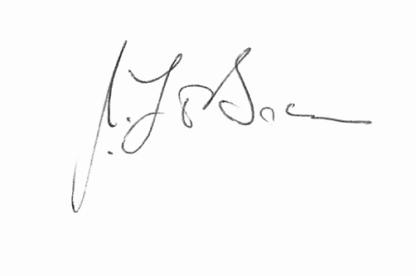
On behalf of our Board and on my own behalf I extend our warmest thanks to our loyal corporate and individual donors, to our dedicated volunteers and to our devoted staff. Together they make it possible to bring comfort and joy to hundreds of our Elderly Friends. They are deeply grateful.

Chairperson - Dr. Jim O’Brien
ABOUT US
Since 1980, Friends of the Elderly Ireland, a non-proﬁt, non- denominational, volunteer-based organisation, has been committed to alleviating isolation and loneliness among older people. We aim to promote independence and well-being. We offer older members the opportunity to make new friendships with each other and with our compassionate volunteers.
Older adults represent the fastest-growing segment of our population, but no one should grow old alone. Companionship is a key component in a healthy ageing process. There are many reports and studies which outline the detrimental effects loneliness and social isolation can have on an older person’s health and well-being.
National and international research shows loneliness and social isolation are now a major public health issue which is twice as devastating to health as obesity. Older people, particularly those over seventy-five, are more at risk from social isolation than many other groups.
Friends of the Elderly provide services free-of-charge to hundreds of older people all over Ireland each year thereby making a signiﬁcant social impact on the communities we serve.
We are service-user led and reach out to older people in their own communities, tailoring our services to meet their needs. Friends of the Elderly acts as an advocate for our older members and helps them to access appropriate local services.

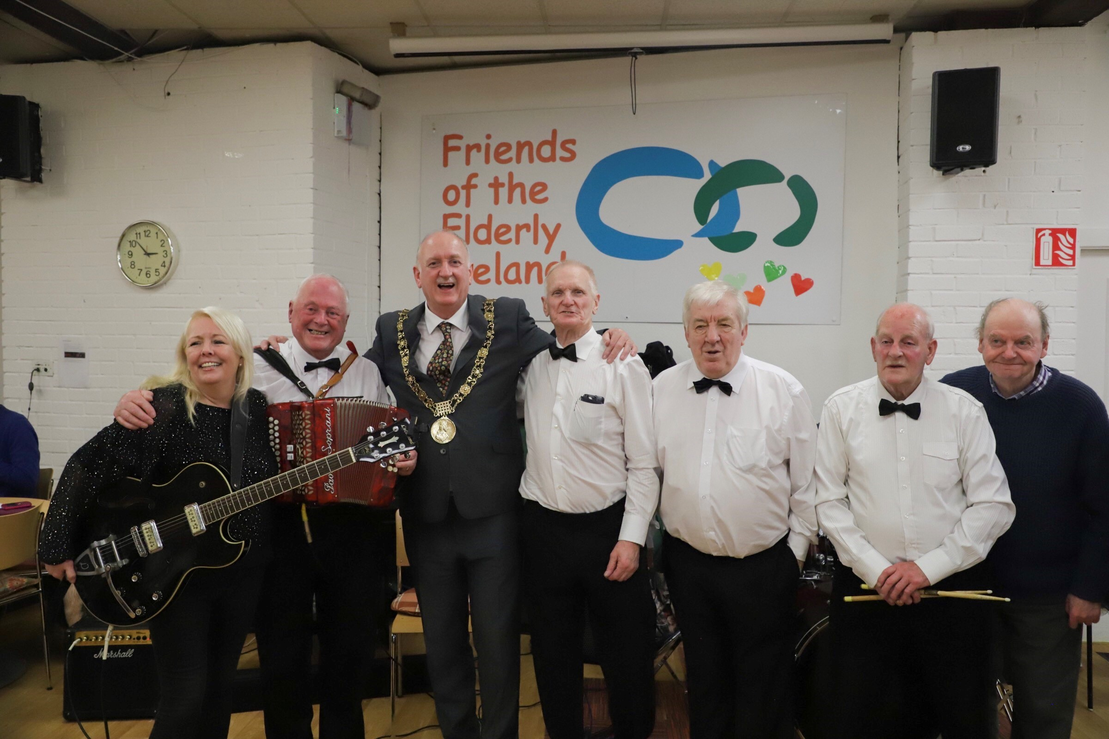
OUR WAY OF CARING Our community-based programmes aim to make it easier and more enjoyable for older members to remain in their homes and continue to enjoy life, often after they have experienced great change. These changes can include widowhood, and bereavement through loss of friends and siblings, emigration and relocation of their children, and health changes. Our approach is flexible and the needs of the individual older person are at the core of what we do. We take a coordinated approach working with statutory and voluntary agencies to achieve our goals of eliminating loneliness and social isolation. We also engage corporates, education centers and the wider community to work with us to achieve our vision. In 2019/20 we will extend our programess to ensure older people do not go without essential food items through winter and at times when fuel costs escalate.
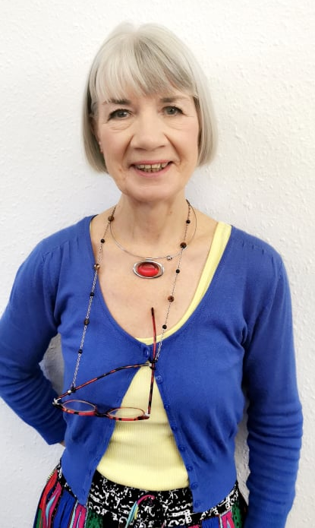
Friendly Call Service Open nationally to those over sixty, this service is growing year on year. In 2016 we made 6,202 calls, in 2017 the service more than doubled to 13,520 calls. This last year we recorded 25,480 calls to people at home or in nursing care. A huge demand for the service led us to offer it to every older person who made contact or was referred by another individual. Our ten volunteers call each member at least once a week, sometimes for a chat or sometimes to just listen. Our calls often throw up issues that our older members need help with and we then refer them to other services or assist with issues they may be struggling with. Older members may prefer this to opening up their homes to a visiting volunteer. Some go on to access our visitation programme after trust has been built, as they understand our matching processes for volunteers in their own community.
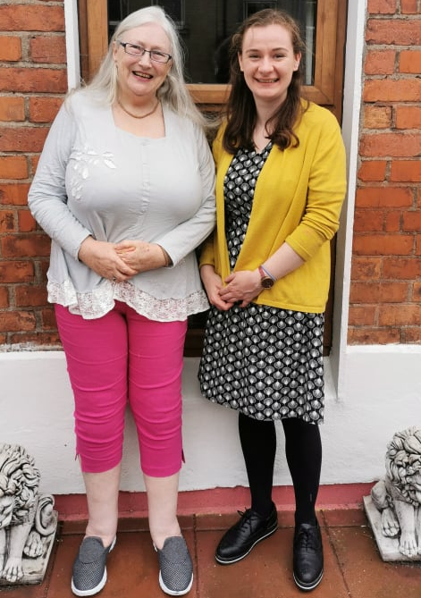
Visitation Programme This is open to the over 60s in the greater Dublin region and is also established in Dunboyne. Each of our volunteers visits one of our older members in their home or nursing home at least once a week. Prior to this there is a careful selection, vetting, training and matching process and an introduction phase in which the volunteer and the older person are supported by staff. They will then agree a time and day for visitation, which can be a social call, outings for coffee, walks or shopping. Sometimes if our older members avail of outings or events our volunteers may be called upon to assist and this is a great alternative to the social visitation in the home. Last year our volunteers made over 5000 visits to older people at home.
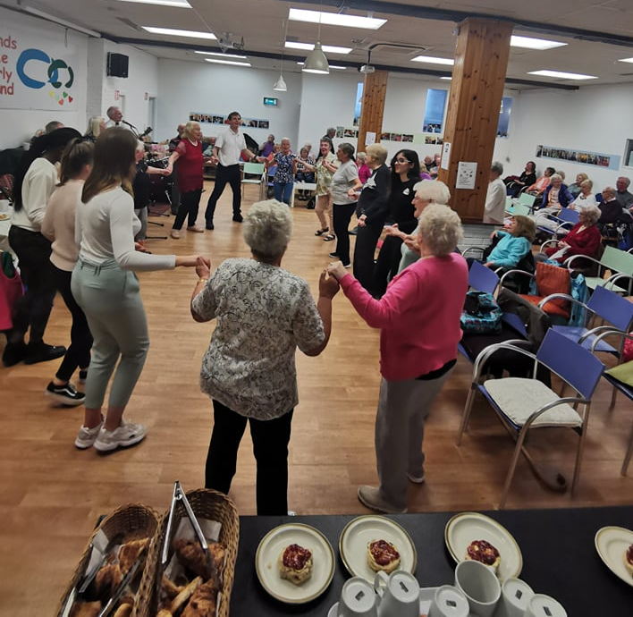
Social Engagement Clubs The range of activities we offer to our members is varied and diverse. Each week we operate a social club where 80 members come together to sing, dance and share refreshments. There is a huge musical aspect to the Wednesday club with an MC and a resident band and our members are usually the stars of the show – with their singing and line dancing. We have chair yoga, a movie club and some educational programmes such as I.T. upskilling, which aims to narrow the digital divide for older people. These clubs offer a warm and welcoming space to meet, learn and enjoy good company. Other ad hoc clubs are run such as gardening, body percussion, and quiz and games afternoons. We also have cabaret afternoons bi-monthly with some fantastic local talent performing in the hall.
Outings, Daytrips and Parties
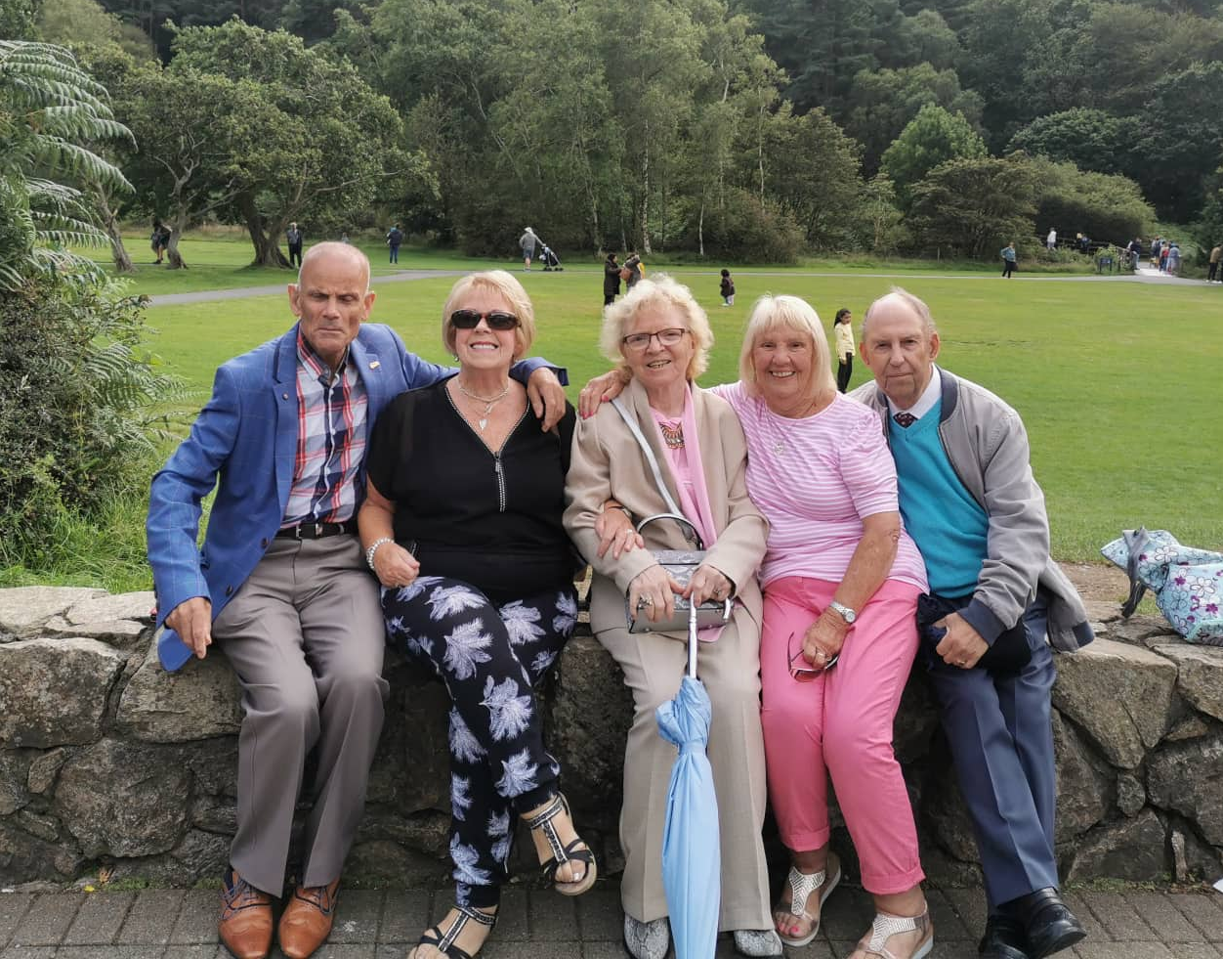
Friends of the Elderly has an extensive outings and parties programme which operates both onsite and off, at various festive times throughout the year and through the summer period. We operate four national trips to places of interest annually, for fifty plus members each time. We also have at least four trips in Dublin for smaller groups on which we aim to bring the less mobile or more isolated, providing transport for those who are in need. In addition, we travel out to afternoon teas and Sunday lunches at various times and attend events together - art exhibitions, music, theater and film.
Onsite we have three Christmas parties with four course dinners, lively entertainment and Christmas presents for all. We also celebrate the other festive periods with themed parties. Our corporate partners provide tickets to shows which we raffle. We always aim to enable social life with others who have similar interests. We also involve our older members in our volunteer recognition evening, this celebration is to recognize their work and commitment to our growing organization. Every member of our social club has their birthday recognized with a present and card and some celebrations at the Wednesday Club for the big ones!
Advocacy and Signposting Our staff team and volunteers work continuously with all our members but also with our referral agents, many of whom are GPs and social care professionals. We work with these partners and also family members (who may be living some distance away) to ensure that our older members get support and guidance and can access good quality services. We ensure our older members know their entitlements, get the assistance they need and signpost services they can call on when they have issues. Our volunteers will inform staff when an older member is experiencing difficulty and may need assistance and this is then taken up by staff or referred to other services which may be able to help.
OUR OLDER FRIENDS
Ageing can be a positive process but for many it can also be a turbulent time in one’s life, with major changes to both body and mind, which can throw up many difficulties for our members. We are here to support people in this phase of their life and ensure they continue to live life to the fullest.
Ellen is 67 and never married, when she was in nursing her life was full with her work, family members, two older sisters and plenty of friends and work colleagues. Life was good and there was not much time to complain. However, after retirement Ellen saw less and less of her work friends, one of her sisters passed away and the other was busy with her own children and now many grandchildren. She found it difficult to meet new friends and people with similar interests. She was nervous about going online and felt unsure of how to meet and build new relationships. She searched the websites one day whilst having coffee and found Friends of the Elderly, she filled the form and the following week she was off to the social club in Bolton street.
“I must admit I don’t class myself as elderly and I was thankful that most members at the Wednesday club don’t either! Since coming down to the club I experienced a new lease of life and made friends with some lovely people. I never realized even some of my neighbours are members which is great. And I suppose everyone including myself is happy with the fact that I have much time on my hands and now I know how to enjoy that time. I look forward to the trips, parties and the odd cabaret and sometimes I do some volunteering in the charity shop, meeting customers and new friends and lots of volunteers and students, it’s really a great organisation to be involved with ‘
Patrick was never really a mixer and after his wife passed away he spent more and more time on his own. His daughter got in touch with us and asked what services we had to offer as they lived on Sherkin Island which is very remote with not much support for people living alone. After hearing about our Nationwide phone service she urged Paddy to make a referral for the friendly call service. He liked the idea of the phone contact, with lots of different volunteers calling on rotation, so he agreed to try it out.
‘I never really thought I was missing out on anything but I was missing my wife and the conversations we used to have, I now look forward to the calls each week from the volunteers and sometimes I get three or four calls a week. We talk about everything and nothing, the news, the weather, the fishing, films whatever! It’s great to catch up and chat and to know someone’s getting in touch regularly asking about my day, it’s quite uplifting and keeps my spirits up’
Mary is mostly housebound due to poor mobility and other medical issues, she is 87 and lives in DCC accommodation. She has supports from a few agencies and since being matched with a volunteer from Friends of the Elderly Visitation Service she enjoys her first long tern friendship at home and out and about!

“Edel visits me at home each week, she lives local so it’s good she is only five minutes away from me. We always try to plan what we will do during the visits. We have similar interests and as we are both good readers we talk a lot about books and exchange them regularly. I have had many trips with my volunteer accompanying me as she keeps in the loop about what’s happening in town and at the community hall and I feel safer venturing out to events when she’s with me. She has been visiting for 3 years now and we have become firm friends, she is so much more than a support to me, we are close and with her encouragement I have more independence and confidence in myself”
OUR VOLUNTEERS

Friends of the Elderly is a volunteer-based organisation. Volunteers are invaluable to our organization and are the very foundation from which we operate. We are proud of the time, commitment and dedication they give to delivering quality services to our older members. Their companionship and friendships change lives. Many of our older friends are also volunteers, giving many hours to assist in the clubs, work at our charity shop and to make calls and visits to our other members. They bring a richness to the experience for all involved and share their life stories of volunteering with the younger students and new volunteers on their arrival.
“I started volunteering with Friends a few months ago when I started my first year of college as I had been to the social club in my TY year and enjoyed it so much. One of my first roles was to help out at the Christmas parties and I was surprised to make connections not only with the older members but with so many other young students, professionals and experienced staff. I had a great time and learned so much about older people and their needs. I also felt good about giving my time and energized by the whole day” Aoife

“I’ve been volunteering now with Friends of the Elderly for 6 years and over that time I’ve been in the charity shop, on the friendly call service and worked occasionally at the social club. I have lots of time after retiring and some energy left as well! I think the organisation is great they do so much but at the same time they struggle with finances and volunteer recruitment. I didn’t realize this until I started with them, but I can say without a doubt in my mind my life has become so enriched because of my volunteering. I would recommend it to anyone with a few spare hours. I met different cultures, went abroad to train with the International federation in France and worked with some amazing students. Rita
“I am a friendly caller and I do two hours each week at the office calling people from my morning list all around the country, I really enjoy the chats. It’s a much needed service as I have come to realize, checking in with people and hearing how their day is going. I have also got to meet some of them face to face as I also volunteered on the Kilkenny trip this summer alongside a corporate group, which was great craic. Morgan
DUNBOYNE BRANCH
Visitation in the Community Our visitation programme, continues to be successful with numerous friendships being built in the locality. Current numbers of visiting volunteers are eight, all of whom regularly visit members at home and contact elderly members by phone.
Our elderly friends are benefitting greatly from these visits as are our visiting volunteers.
Nursing home visits are ongoing and include two local nursing homes. We currently visit elderly people on a weekly basis. We are also taking some of our elderly members to mass in Dunboyne on Sunday. We hope to build on this service and grow the numbers of members availing of our services.
Coffee Club
The Coffee Club is hugely successful and continues to grow in numbers. The Oak Centre in Dunboyne, facilitate these clubs every 6 weeks. Numbers have grown to up to 80 elderly people attending each time. The transport provided by ATN buses is invaluable. Our music continues to be provided by Robbie Fallon. Local businesses Super Valu and Avoca provide a lot of the confectionery for the morning. We have a cohort of extra volunteers that help during the coffee clubs. Transition Year students attend also from St Peters College and provide great hands on help and support to the members attending.

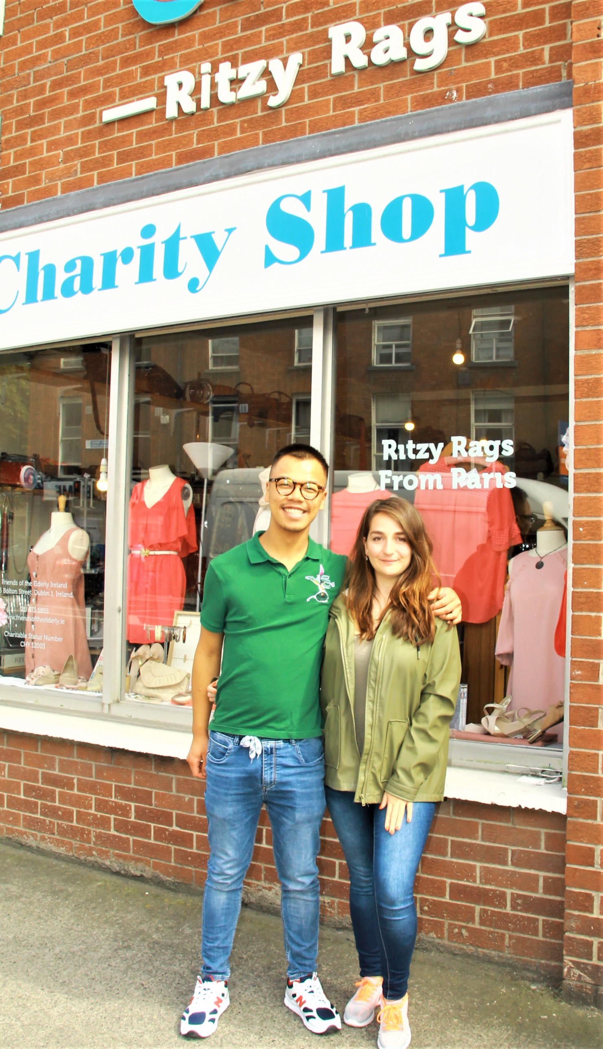
INTERGENERATIONAL PROGRAMME in 2018 FOTE participated for the first time in Service Civique which enabled us to take two French Students for a one-year placement. This valuable programme is funded by the French Government and it offers young people under 30 the opportunity to volunteer for up to one year internationally on approved projects, and to work alongside our Irish and other European volunteers.
This programme promotes informal learning and personal development and working in Friends of the Elderly volunteers gain valuable practical experience. After much planning the first year of the new programme was a huge success with Alex and Naye enjoying their time living in Dublin and also perfecting their English language skills. The two full-time French volunteers have enhanced our services and brought another culture and a new dynamic to our work in 2018/2019.
Below is an account of the first year from one of our students:
‘On completion of my volunteer service with FOE Ireland, I had evolved professionally but most importantly personally. My main goal was to be helpful and available to others and I reached it through FOE. I experienced a lot whilst working with members of an organization who devote their time to the well-being of their elderly community. This work ensures that older people won’t feel alone and can continue to enjoy their lives.
I was able to attend an exceptional number of events - Charity awards, DIT presentations, the Mansion house, and a trip to Newry, to name but a few. I also helped organize weekly activities like the Wednesday club, the movie club and Christmas and the St. Patrick’s day parties. I will miss all this very much and I have great memories because the Irish make these things particularly special with their warmth, their joy, their friendship, and their crazy funny madness!
Besides helping with the festivities I worked in the charity shop, to ensure good management. I also did administrative tasks and friendly calls at the office. You will understand that the tasks were very varied and diverse This is what I liked the most because it allowed me to develop my autonomy and flexibility.
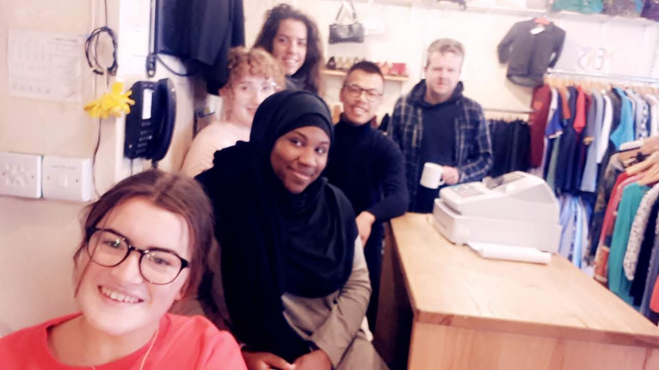
To end - this year was rich in emotion, between laughter, incomprehension, joy with all the volunteers that I met from all over the world and the wonderful team at FOE, whom I want to thank from the bottom of my heart. I felt accepted in my entirety, I felt valued and understood. I want to thank you for the place and respect you have given me. I want to thank you for the luck and trust you have given me and especially I want to thank you for helping me to exploit the potential that I don’t see in myself’ Naye Service Civique full time volunteer

COLLEGE INTERN PROGRAMME
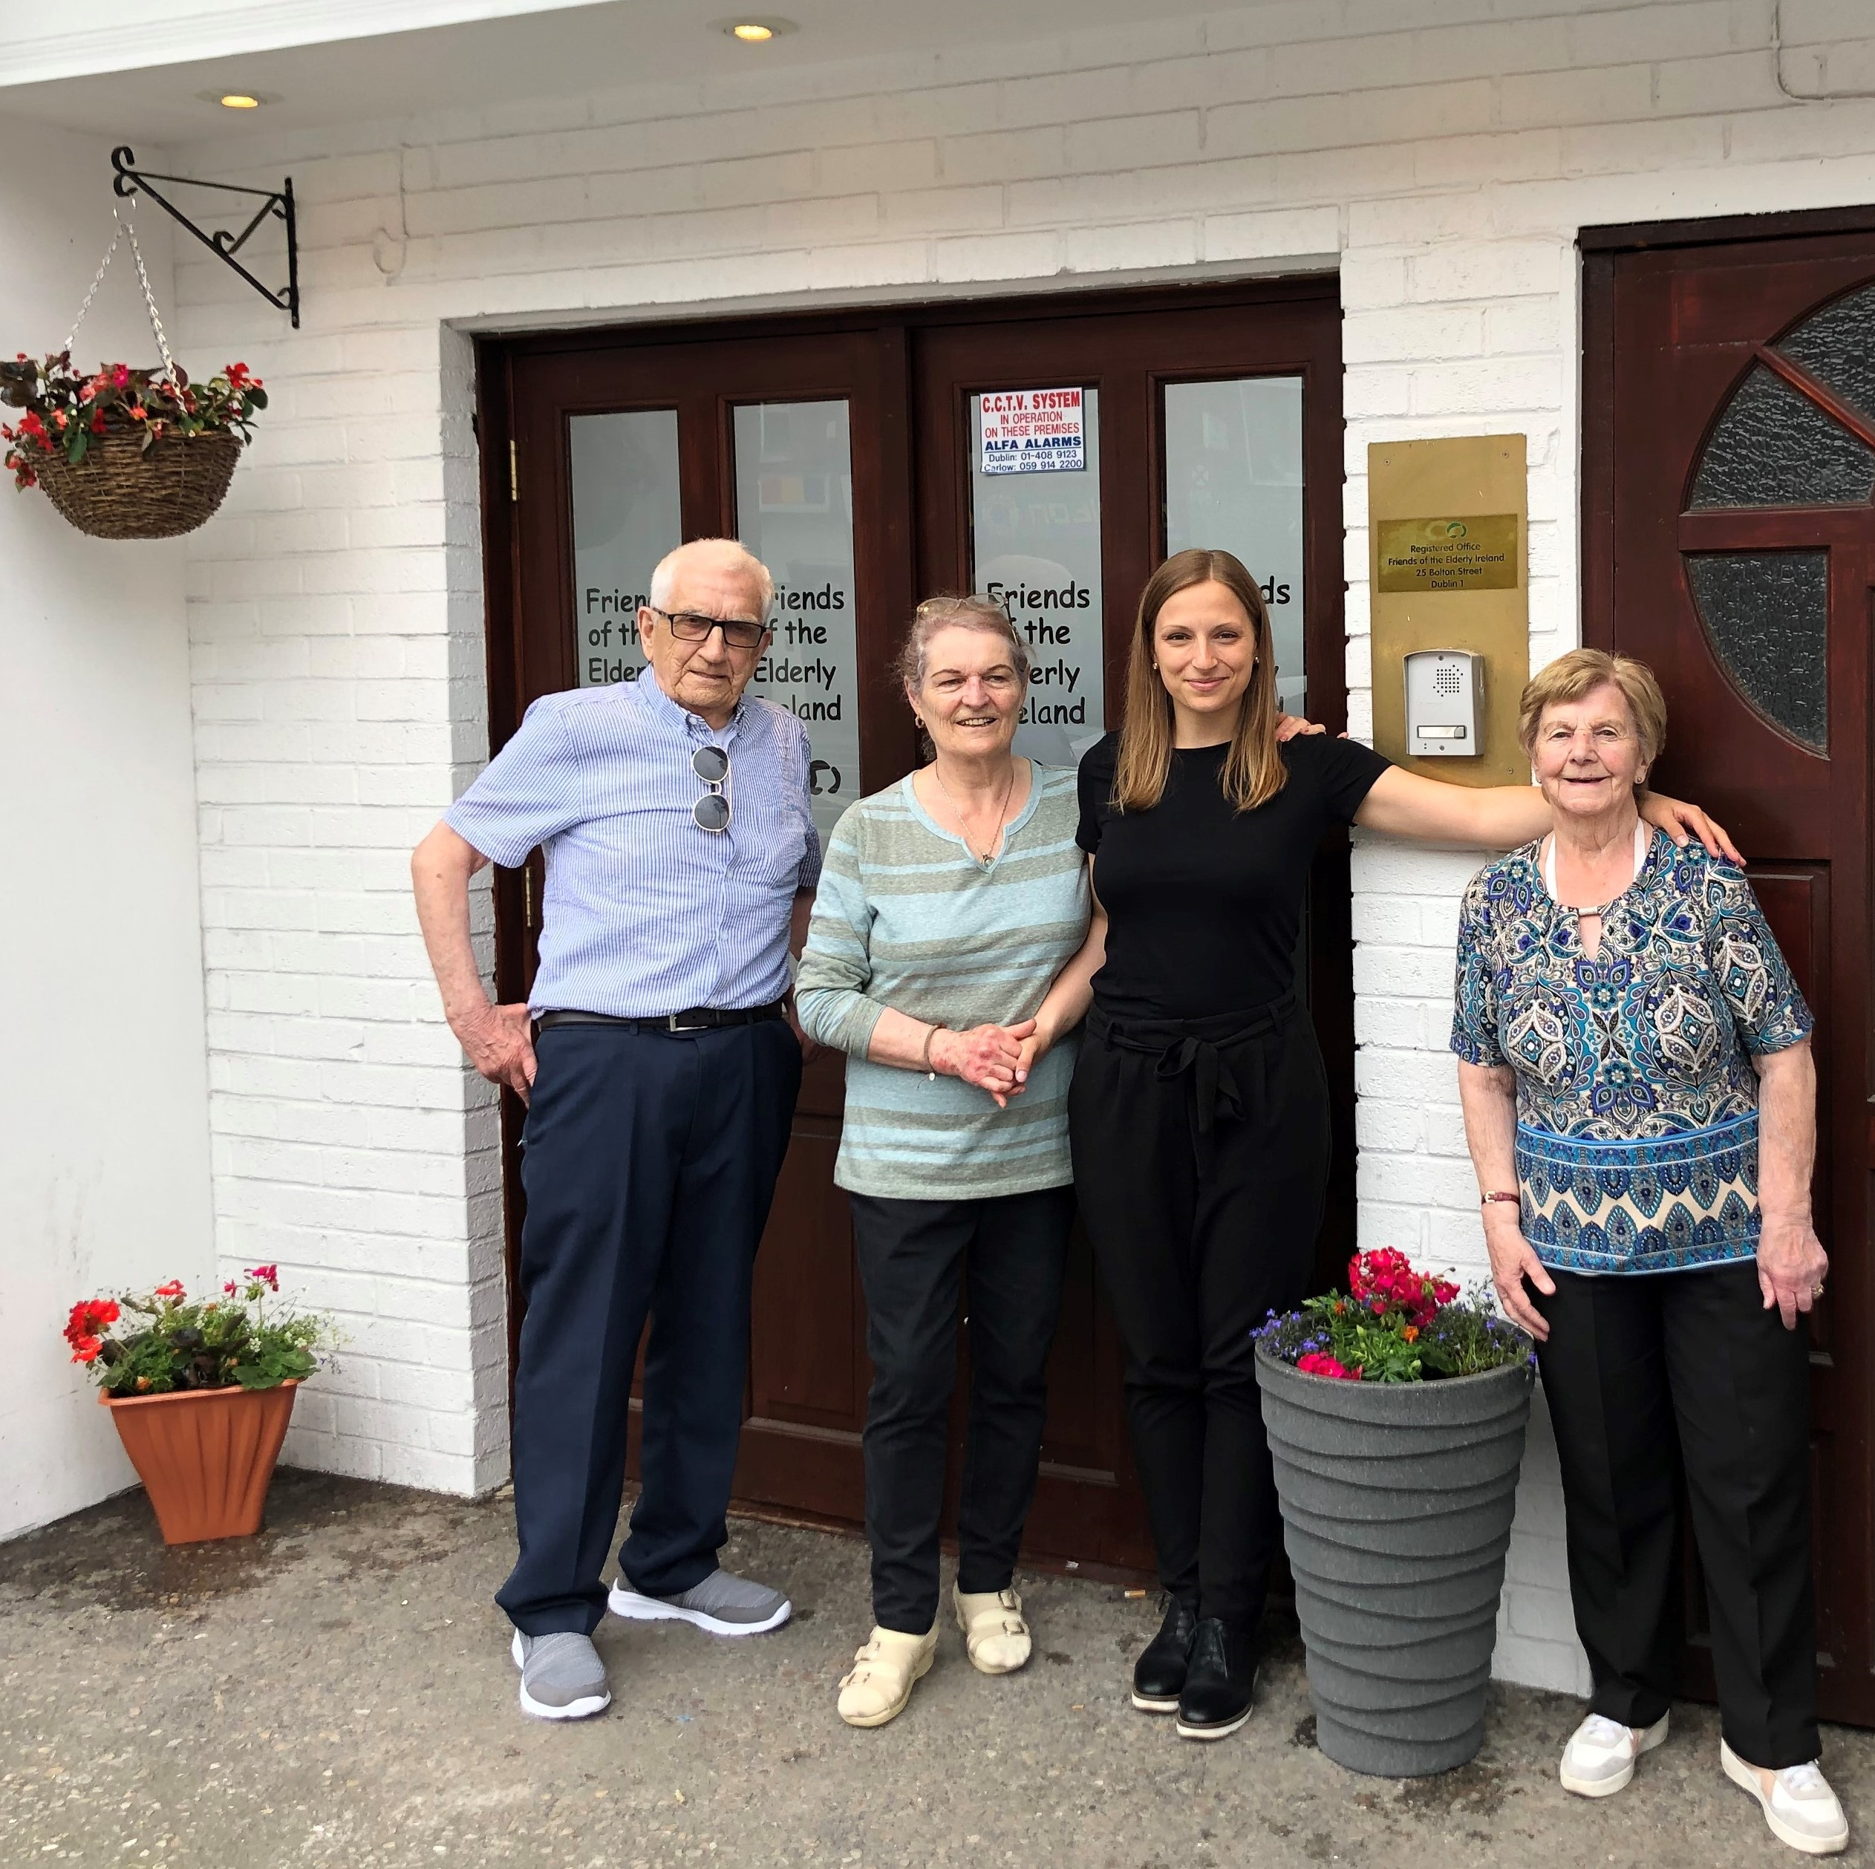
Friends of the Elderly offers students from Ireland and around the world opportunities to undertake placements to gain valuable experience in the social and community sector. They can work directly in our older persons’ programmes or in administration, or in our Fundraising and communications department. Friends of the Elderly are developing their contacts with third level colleges in Ireland and are currently working on projects with DIT, UCD, and Trinity. We work with many overseas students who come to Ireland to improve their English and gain a new perspective on how organizations such as ours work.
‘This year the great chance of being an intern at Friends of The Elderly was given to me. I completed six wonderful months with many warm-hearted and kind staff members, volunteers and especially older people. During this time, I worked in the office and dealt with admin responsibilities, I helped out in the Social Clubs as well as in the Charity Shop, I was on day trips with the elderly and – as my personal highlight – I ran my own project with them doing different activities such as Bingo, Body Percussion and Handicrafts. That was lots of fun for everyone and I really enjoyed spending time with the Elderly who always brightened up my day. My internship at Friends of the Elderly taught me so much about older people and their needs, I gained new skills and achieved personal development. This is so valuable and will not only be helpful for my later work as a social worker, but also in my private life. I want to thank everyone for giving me this unique experience and for making me a better version of myself. I had such a great time at Friends of the Elderly, I’ve made amazing memories and I will miss being here.

- Rebecca Maisel – Hochschule Coburg Germany

SECONDARY SCHOOLS PROGRAMME

Friends of the Elderly run a schools programme to increase young peoples’ knowledge of ageing and the challenges older people face, and how these challenges may lead to social isolation. Through our schools programme we hope to dispel myths about ageing and older people. We aim to do this through student participation in activities with older people both in our Social Club and with older adults living near their school. In this way students discover the great beneﬁts of intergenerational friendship for younger and older people alike.

We have an in-house schools programme which is very popular with students. It gives them the opportunity to share their skills with our older members while learning about life in years gone by. Social clubs, especially intergenerational clubs like ours, have been found to be one of the most effective ways of combating loneliness among older people. Friends of the Elderly are always glad to speak at schools and colleges about the issues relating to social isolation.
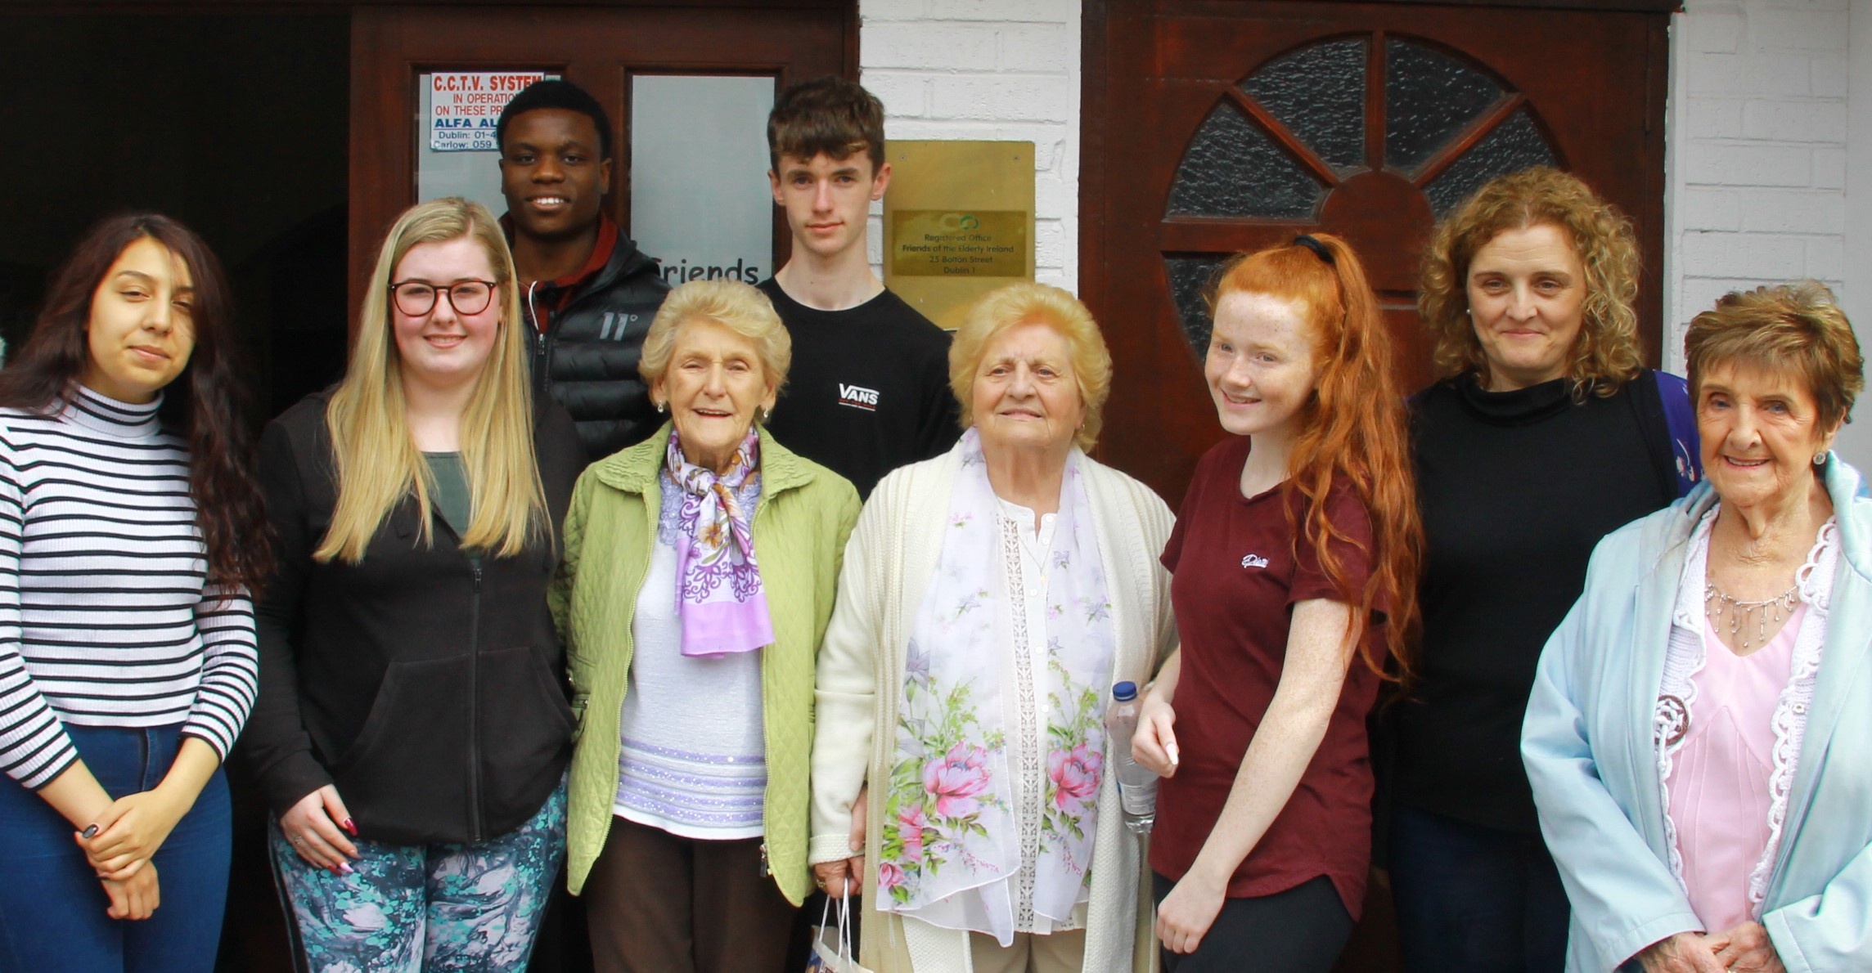
We work with Gaisce Students, transition year students and summer volunteers, and also with other educational facilities who promote less traditional ways of learning, such as Youth Reach. We work with many diverse groups and like to be inclusive in our approach so as to enrich the experience for both young and old. We facilitate learning and work experience for people with disabilities. Placements can be for as little as one week or in some cases 24 weeks for the President’s Award. They stay for as long as is needed to gain the confidence and experience they hope for or maybe just because they enjoy it so much. Either way they all receive the Young Friends Certificate of Recognition on completion of the placements.
“I did a summer placement in Friends of the Elderly and found the experience challenging but enjoyable. I wasn’t sure what to expect as I was in education and had not had the opportunity of being in a real work environment until then. It opened my eyes to a new world. I worked on the social engagement programme, tried my hand in the shop and some office work. The experience really changed my life and my view of older people. I also realized where my skills lay and gave me more confidence “David (Autism Initiatives)
“I completed my TY placement at Bolton Street, a daunting experience at first but before too long I was meeting and greeting in the social club, doing the raffle and having a good time with all the members and staff. I learned a lot about administration and came out the other side knowing so much more about older people and their needs’” Daniel (TY Student)
CORPORATE SOCIAL RESPONSIBILITY PROJECTS

Some of our corporate partners this year were: Aviva, My Home Care, Phorest, Investec, Unilever, and M&S.
Aviva and My Home care sponsored our trips in the summer programme to Kilkenny, Newry and Wexford. Their staff came on board to assist on the day with 50 older people and made fabulous goodie bags.

Other partners such as Investec and Phorest assisted and supported our annual Christnas parties and sponsored our Christmas cards and presents. This allowed over 210 older people to have Christmas dinner and entertainment here in the community hall with the great help of their volunteers. Their amazing staff arrrived on the day in such good spirits and gave our members a party they will never forget!

Unilever kindly donated pallets of food and household goods which we distributed to our older members throughout the year. This annual donation allows us to offer our older members a lifeline when it is most needed as many of them depend entirely on their state pension. A new hamper programme will also start in 2019 supported by FEAD (Department of Social Protection) which we hope to roll out in September 2019.

M&S have been a constant support being right on our door step they have been so kind with practical support and donations. Without them and Unilver we would have had no prizes or presents at our events.
We have also had much needed practical help onsite with deliveries, painting, store room and many bucket collections in which our corporate partners helped.
Thanks to all our sponsors for their generous time and effort to enable us to continue our work. And hopefully we will have plenty more support in 2019/2020.

BEING ACCOUNTABLE

GUIDING PRINCIPLES: We take great care to ensure that all donations and legacies received are used efficiently and effectively. All funds available over and above one year’s current operating costs are used to improve and expand our services. We are legally obliged and honour bound to ensure that each and every donation and legacy received is duly recorded and promptly acknowledged. We also ensure that all funds received are used to the best possible effect to alleviate loneliness and isolation among the elderly who live alone.

OVERSIGHT AND REPORTING: The Board has established detailed internal book-keeping and accounting rules governing the treatment of all receipts and expenditure as well as closely specified banking procedures. Our manager records all financial transactions and presents them to our external accountant who prepares detailed bi-monthly accounts for our Finance and Administration Board sub-committee. This subcommittee comprises the Chairman, the Hon Secretary and the Hon. Treasurer (assisted by the manager) and its report to each bi-monthly Board meeting accounts for each deviation from the Budget adopted by the Board prior to the start of the financial year.

ANNUAL AUDIT AND TRANSPARENCY: The company accounts of Friends of the Elderly Ireland are audited annually by our auditors Smith and Williamson Ltd (Chartered Accountants). The preliminary presentation of the draft Audit Report to the Board takes place in early autumn. As soon as minor questions (if any) arising have been answered to the Auditors satisfaction the final Audit Report is presented to, and adopted by, the Board at its October meeting and presented to the Shareholders AGM which follows immediately after this Board meeting. The Audit thus adopted is then duly registered with the Companies Registration Office by our Auditors. The Audited Accounts are then entered on the Friends of the Elderly Ireland website.
OUR POLICY ON RESERVES: Our donation and shop income fluctuates from year to year while legacy income – being entirely unpredictable – is budgeted at zero. As a general rule we endeavour to keep one year’s expenditure in reserve. When reserves fall below this level every effort is made to restore this level as soon as possible. The audited accounts for 2018/2019 showed a deficit of € 83,160.00 which left us with €224,271.00 cash in hand at 31 March 2019. This outturn obliged us to introduce a tightly controlled budget for 2019/2020 – with expenditure held to a strict minimum and ambitious fundraising targets using traditional and new methods.
AUDITED ACCOUNTS are on our website www.friendsoftheelderly.ie

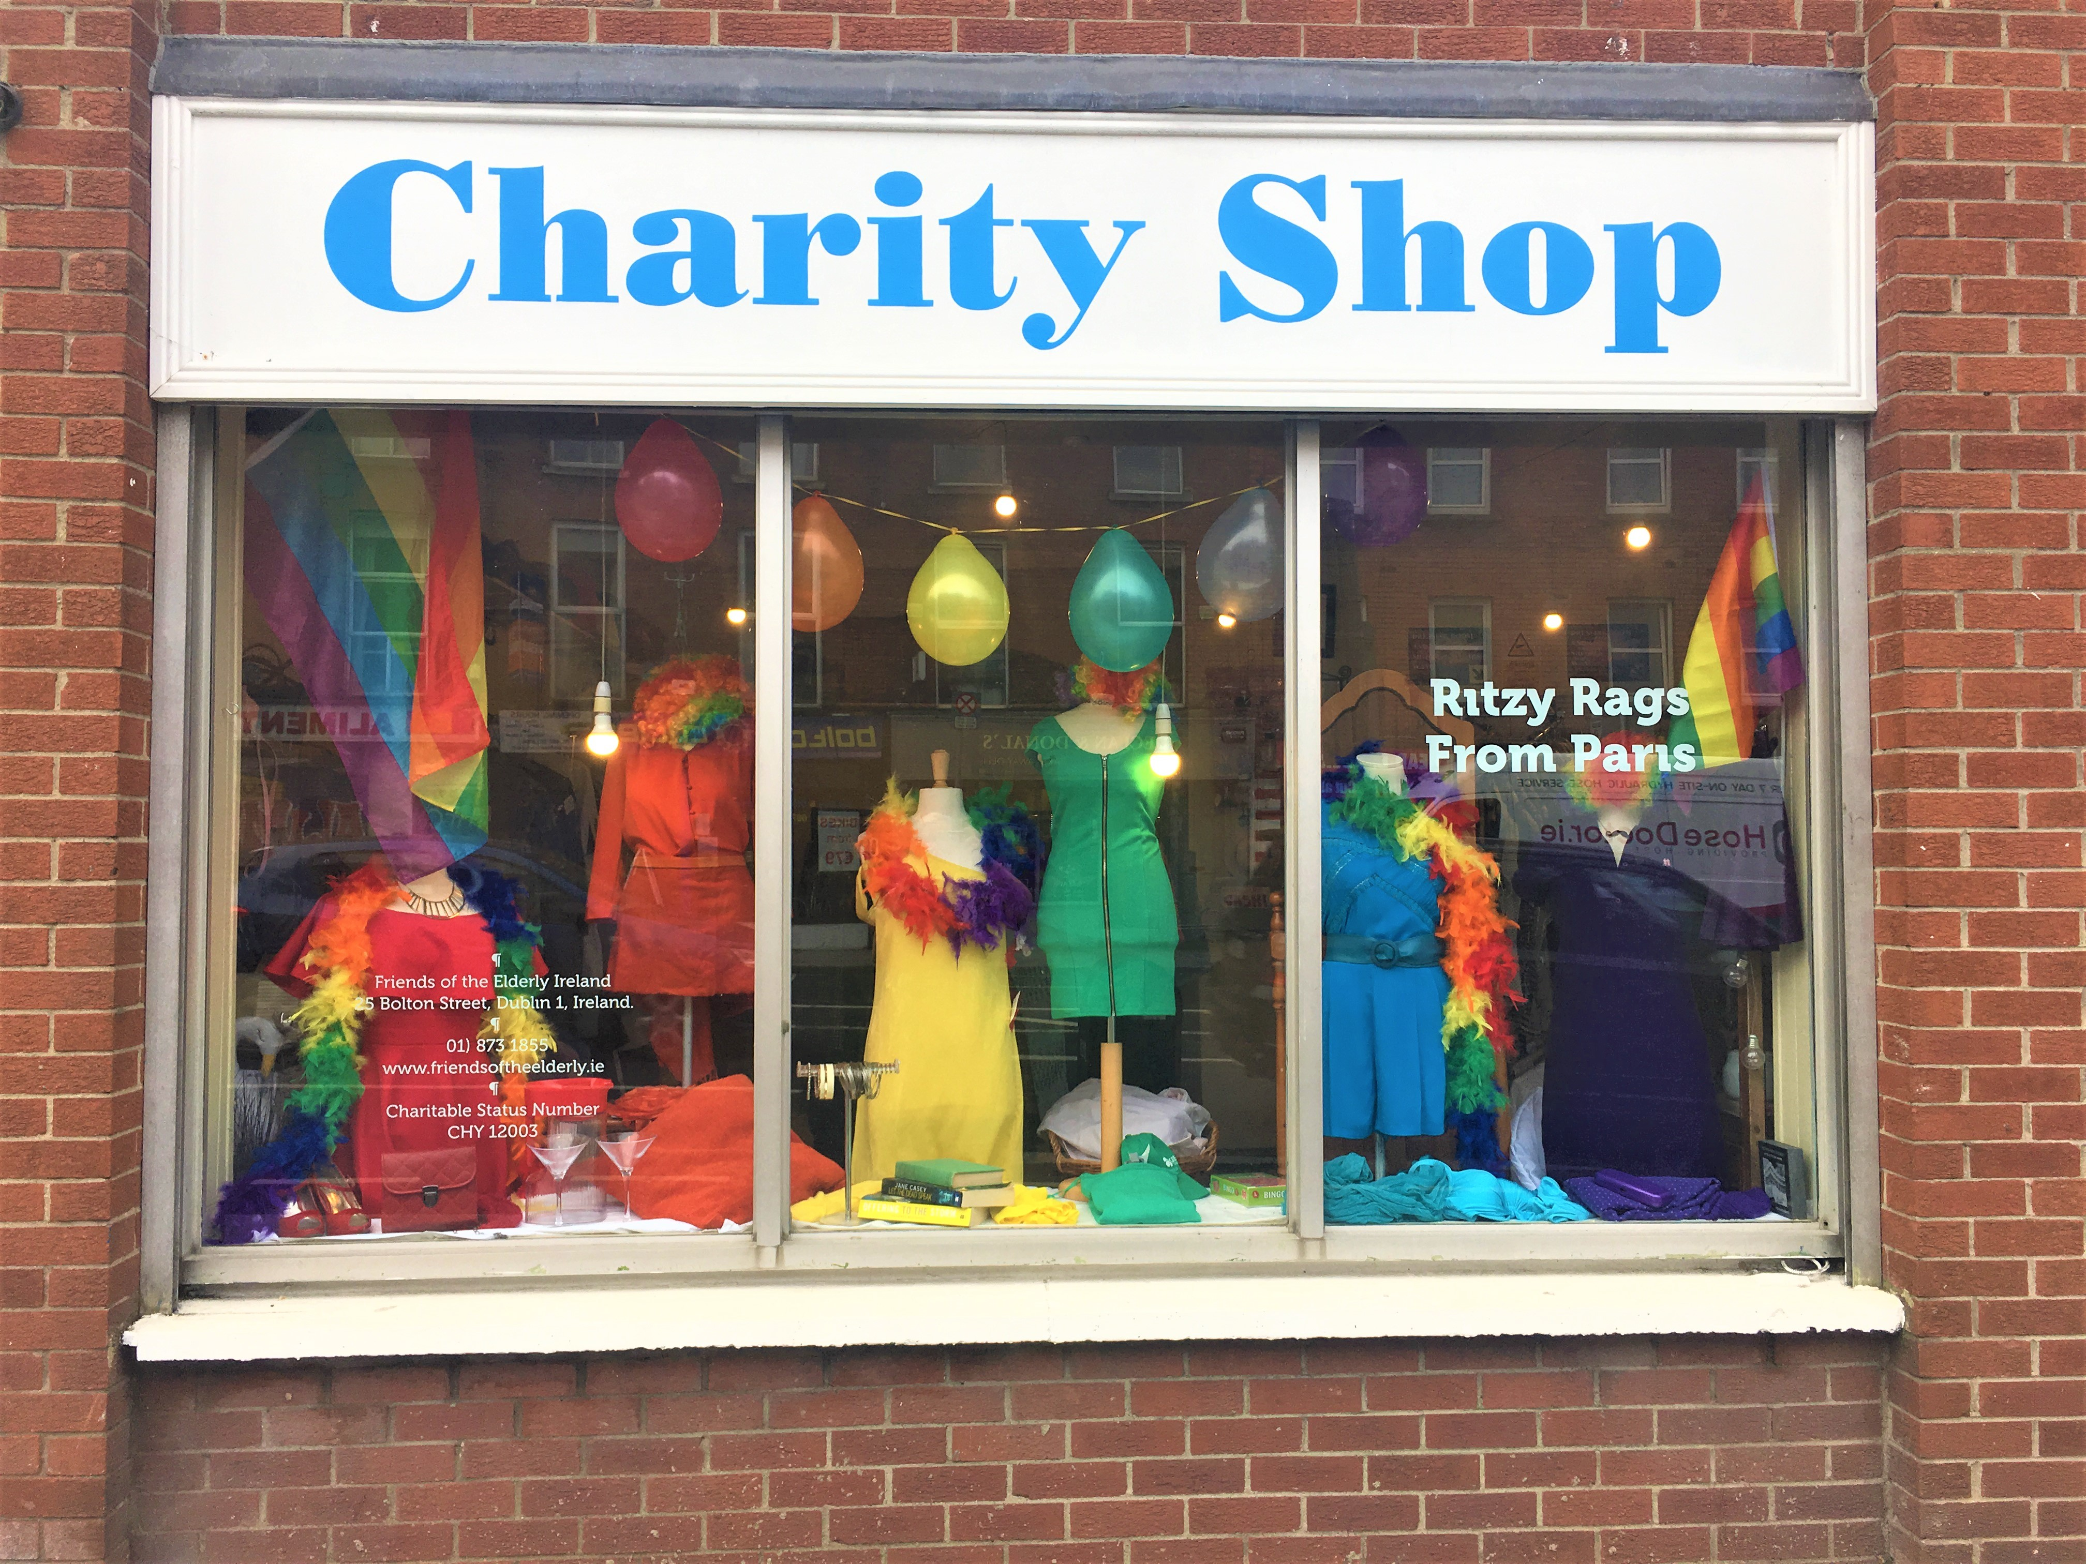
Our Beautiful Bolton Street Charity Shop

Ritzy Rags has been in operation for over thirty years now and this year with the help of some new volunteers we have extended our opening hours during the week, and reopened on Saturdays. We are all still enjoying the French flavour of the shop. It’s a real touch of Paris.

We continue to receive two large deliveries each year from France, which gives the shop a unique quality. The French labels are fabulous and prices are still what you would expect in the charity shop sector.

We are grateful for your support for our shop. This helps us to fund some of our projects and adds to the social inclusion programme for our older members. Many of our recently retired members continue to volunteer alongside students, interns and young volunteers. It plays a big part in our intergenerational programme and it is our open door to the whole community.

Some of our corporates also assist by making a call out for donations to their staff and from this you can find many new items of clothing and some designer items!

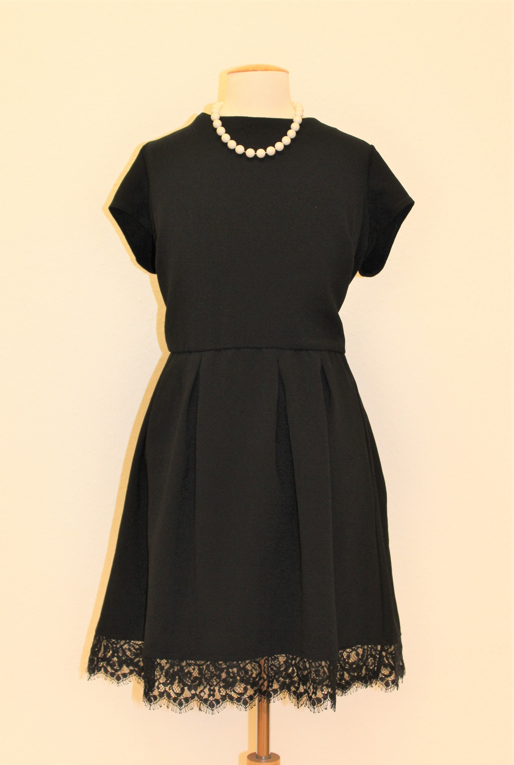

We cater for all styles and price ranges and for young and old. We have both modern and vintage sections and it’s simply a lovely place to shop or browse.

Drop by and say hello to our good friends and you might find something special …………

2018/2019 Activities

OUR FUTURE PLANS
- To launch a new hampers programme: with assistance from the Fund for European Aid ie: FEAD
- Highlight the United Nations International Day of the Older Person through an event on 1st of October each year.
- Provide transport to those who find it difficult to access our programmes
- Develop the role of volunteers within the organisation
- Raise awareness of the public health issues related to loneliness
- Improve service delivery and monitor quality standards
- Continue to operate according to our Values, Vision and Mission.
- Increase our fundraising initiatives to improve and expand our services

Our activities 2018/2019 included
the following:

April 2018
2018 Volunteer recruitment programme begins
2018 Student TY applications opens
Tech Club Members Graduate
3 Year strategic Plan is launched
Musical Matinee Trip

May
Youth Reach Collaboration
Low mobility day trips begin
Safety talks programme
DIT college collaboration starts
Volunteer training
GDPR internal audit
Cheese and wine cabaret

June
Service Civique recruitment opens
E light Energy Drive with Bord Gais
Penn State University Collaboration
Attended Loneliness taskforce launch
Summer programme starts – Trip to Gorey
Trip to the Dublin Zoo
Intern Programme commences
Big Breakfast Club – Skidmore College USA
Internal staff training programme

July
Training day for volunteers
Trip to Kilkenny – Summer Programme
Bastille Day Celebrations
College of William and Mary USA design project
Safety Talks programme

August
Trip to Carlingford Lough – sponsored by Aviva
Chair Yoga
Trinity College Collaborations – Old TV Project
DIT Working with Communities
Sunday Lunch Outing

September
Gaisce Students recruitment and induction
Overseas internship programme commences
Mobility trip to Malahide Castle
Drop in Coffee Dock commences
Tech Club commences
Weekly Movie Club starts

October
Italian Dinner Date
Halloween Cabaret party
International Day of the Older Person celebrations
TY Inductions
European Working Group
Volunteer Recognition Evening

November
Winter Warmer Cabaret
Christmas Cards Campaign
Thai Chi and Agility Classes
Afternoon teas

December
Christmas Party x 3
Volunteer of the year awards with our finalist Jim Moore

January 2019
New recruitment of staff and Community Employment Scheme placements
Maynooth University collaboration
Age Friendly Alliance meeting
Intergenerational programme starts for 2019
Trinity V de P Film Club

February
TY Programmes starts
EUSA Internship programme starts
14/02 – Valentine Party
17/02 - Volunteer recognition day

March
Agility classes commence
Volunteer Recruitment
St Patrick’s Day party
Weekly Social Club continues on Wednesdays
Cabaret afternoons
Friendly call and Visitation programme audits

PHOTO ALBUM
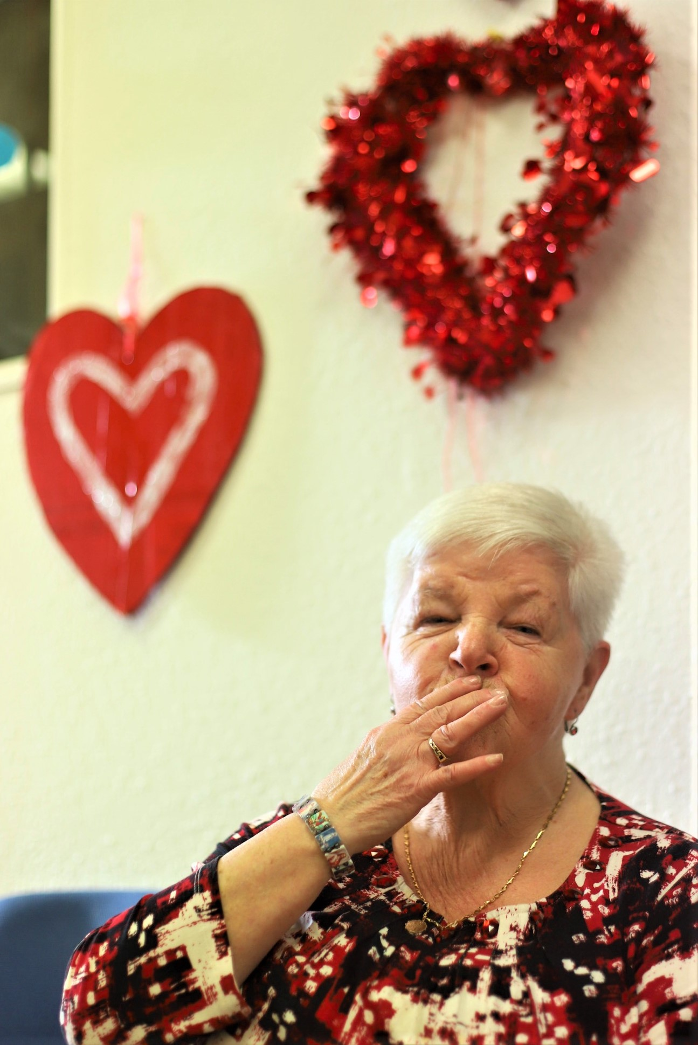
Good- bye to all the students who came and introduced us once again to a different culture
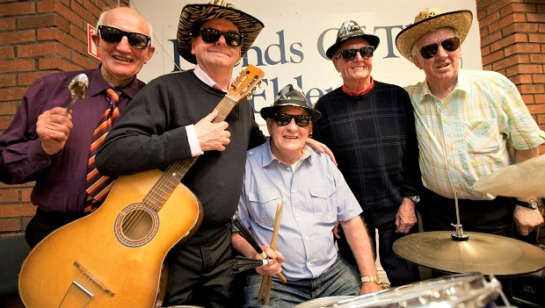

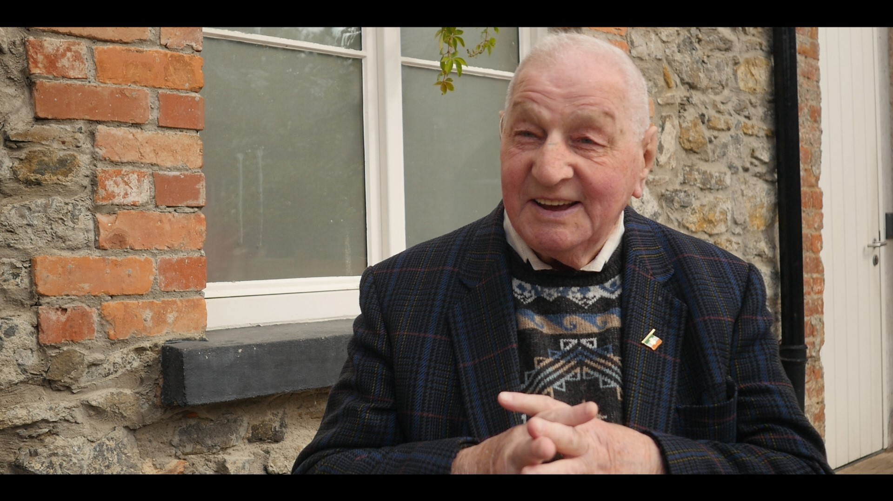
Thank- you to our MC John St Ledger and the Bolton Street band for the magic of the music and of course the laughs!
Super congrats to our longtime volunteer Jim Moore who was recently awarded a Finalist Certificate by Volunteering Ireland

And Cover. What is a party without good friends? – our dear friend Maisie Flood lived to the ripe old age of 104 - she was the life and soul of so many of our parties, and is fondly remembered

THANK YOU FROM OUR BOARD
Your support is vital – Friends of the Elderly’s achievements are only made possible through the support of our volunteers and donors. As the demands on our services grow so does our need for your continuing support.

On behalf of our older friends, we would like to thank all our volunteers who have supported Friends of the Elderly throughout the year. It is you, our volunteers, who enable us reach out to so many older people each year.

A special thanks to the International Federation of Friends of the Elderly and to the Little Brothers of the Poor in France (Paris) who have supported us by providing a platform for shared learning and information exchange and encouraged us to keep going when times are challenging.
To our Donors, we say a heartfelt thank you. Your support enables us provide a growing range of services to many older people who find themselves alone and isolated.

Our Honorary Ambassador
Dr Ronnie Delany

Our Board
Dr. Jim O’Brien Chairman
Chris Carroll Hon. Secretary
Tom Horan Hon. Treasurer
Liz Roche
Deirdre Devaney
Catherine Egan
Omega Goodwin

Special thanks to John Casey – who recently retired after many years as Hon. Secretary and to Emma Colleary who also retired from the Board this year

How to get in touch
Phone: 01-8731855
email: info@friendsoftheelderly.ie
website www.friendsoftheelderly.ie

Thank you for being a GOOD friend of the elderly

