TEACHERS SUPPORT PACK
“OLD FRIENDS ARE BEST”

ACTION PROJECT

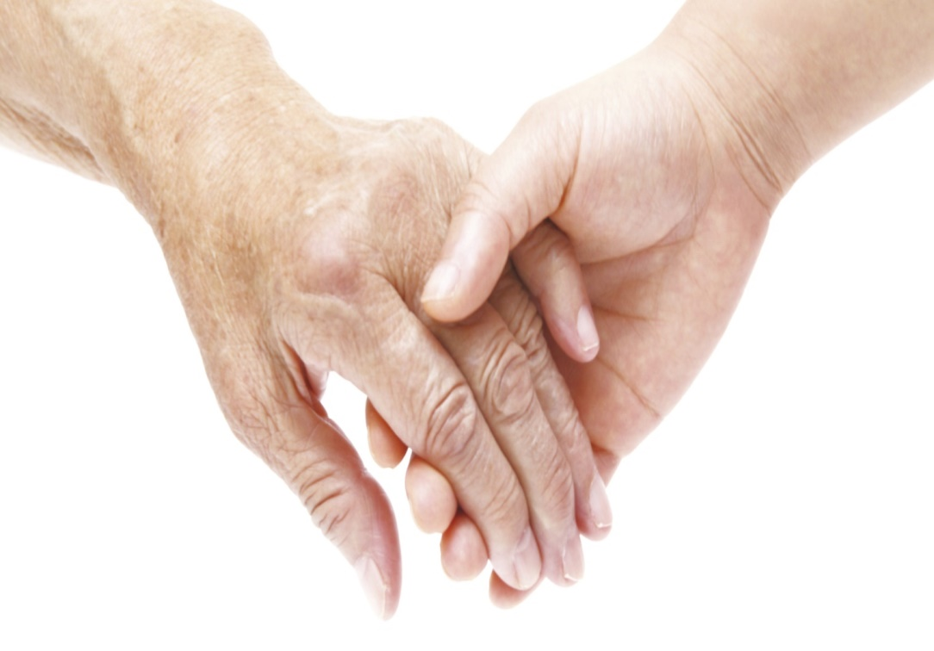
C
S
P
E
Module
Contents

Introduction 2
About Friends of the Elderly 3
CPSE Project 5
Preparing an Intergenerational Activity 8
Project preparation 8
Stage 1.Getting To Know About You 10
What is our concept of “Old”? 10
Facts about ageing 12
Ageing happens to us all 15
Review Seniors are Cool (on Youtube) 20
Human Rights and Responsibilities 21
Ageing Sensitivity Training 24
Station 2. Hearing Changes 27
Station 3. Changes in Touch and Dexterity 28

If you are interested in developing an intergenerational activity, we can facilitate a wide range of activities onsite here at Friends of the Elderly. Or can deliver training to your students that give ideas and a better understanding through a guide to class room based projects.
Please contact:
Bernie Curran or Deborah Costello
Intergenerational Programme Coordinators
01-8731855 or info@friendsoftheelderly.ie

Introduction
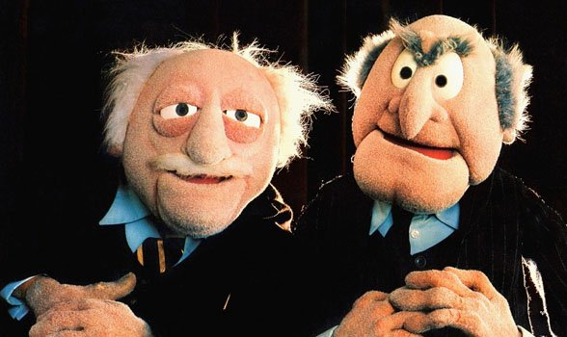
Welcome to our Friends of the Elderly “Old Friends are Best” Teacher Support Pack. The aim of our CSPE programme is to increase young people’s knowledge of the aging process and in doing so help to create a better understanding of what challenges older people in your community may face and how these challenges may lead to social isolation.

This is accomplished by sharing experiences and skills and fostering a friendship between the young person and older members of the community. Students will learn, through many interactive activities, what if feels like to grow old and what happens to our bodies as we age.

This project will give students an opportunity to understand their own attitudes about growing older, to develop new communication skills that can be used all through your life, and finally, to form new or enrich current friendships with older people in their community.

About Friends of the Elderly
Since 1980, Friends of the Elderly Ireland, a non-profit, volunteer-based organisation, is committed to alleviating isolation and loneliness among older people while promoting their independence and well-being. We offer compassionate volunteers the opportunity to make new friendships with our older members.
Our History
The organisation was founded by a French nobleman, Armand Marquiset, in 1946.At the end of the World War II, Armand formed Little Brothers of the Poor - Friends of the Elderly to help isolated and lonely elderly people who had lost their families in in the war. “The greatest poverty,” he often said, “is the poverty of love,” which was reflected in the motto, “flowers before bread.”
His powerful example attracted many volunteers in France and beyond. Little Brothers of the Poor – known now as La Fédération Internationale des petits frères des Pauvres – had spread to nine countries around the world including Ireland.
Friends of the Elderly Ireland provide services to over 1000 older people annually; making a significant social impact on the communities we serve: Our Programmes include
- Visiting Programme
- Friendly Call Service
- Social Engagement Club
- Short Holidays, Day Trips & Events
- Parties and Hampers
- Intergenerational community engagement
- Advocacy and referrals to community resources
Older adults are a precious resource and represent the fastest-growing segment of the population. But no one should grow old alone. Companionship is a key component in a healthy aging process.

CPSE Project
Students will find that the CSPE program concepts of Human Dignity and Rights and Responsibilities are the most relevant topics to cover when choosing to examine the work of Friends of the Elderly as part of your Action Project. However all 7 concepts can be applicable once explored further.
Seven Course Concepts
- Human Dignity
- Stewardship
- Development
- Democracy
- Law
- Interdependence
- Rights and Responsibilities

Topical Issues related to our project
- Human Dignity | - Human Rights
- Respect, Understanding and tolerance | - Personal & Social Responsibilities
- Stereotypes and Ageism | - Philanthropy
- Demographics | - Non-profit organisations
- Ageing Process | - Citizenship
- Social Isolation | - Volunteerism
- Social Contact – a Basic Human Need | - Community Involvement
- Age Friendly | - Intergenerational Learning

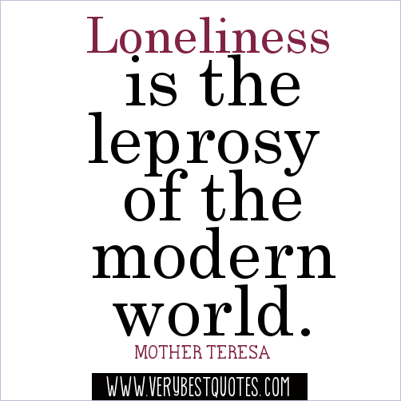
- Human Dignity: Pupils should be aware of the dignity which every individual should be accorded as a human being, and of how the provision of basic needs (e.g. food, health, security, education, social contact) is vital to human dignity.

- Rights and Responsibilities: The first article of the Universal Declaration of Human Rights recognises the inherent dignity and equality of every person.

Key Skills which will be developed include:
- Communication - Learning how to effectively converse in a group and on a one to one level with older people
- Critical Thinking - Students will learning how to assess their own and societies perceptions of the ageing process
- Personal Reflection - Students will be given the opportunity to look introspectively on how their own prejudices may have coloured their views of older people in their community and the changes they can make to remedy this
- Interactive Participation - By interacting directly with older people either in our social club or in retirement centres in your area, students have the opportunity to learn what it is to be older and the challenges that come along with the aging process

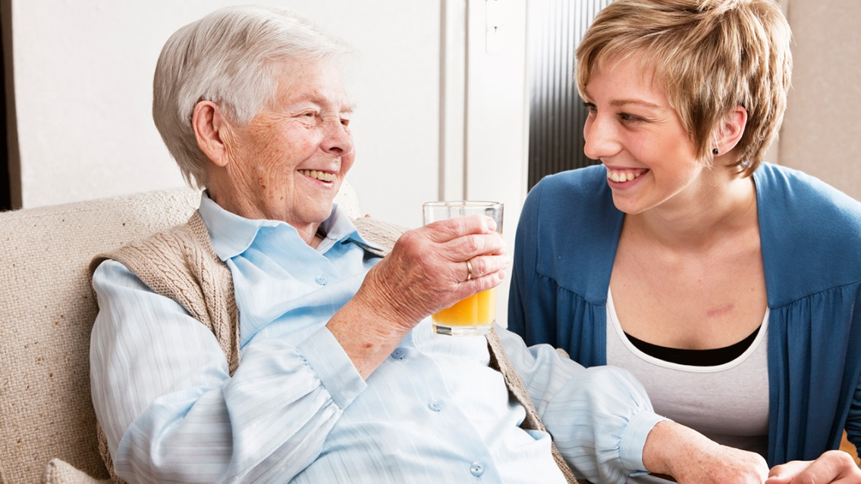

In Friends of the Elderly we recognise the basic need of every human being particularly older people to social contact. It is important that we have people around us to support us and loves us. Loneliness and social isolation can lead to depression, anxiety and loss of human dignity. It is also important that older people particularly the most vulnerable have a responsible community that protect their human rights.
Young Friends of the Elderly CPSE Programme has been developed to encourage students to engage with older adults and to have greater awareness and understanding of the challenges that older adults face and through an action project respect, empathy and a sense of community will be developed.
As part of our project we hope to dispel some myths about ageing and older people and through participation in activities with older people in our Social Club or with older adults in the community nearer to the school, learn what valuable members of society older people are and that there are benefits to intergenerational friendship for both younger and older people alike.
Integrating Intergenerational Activity into the CSPE Action Project
The activities in this pack are designed to provide teachers with ideas to work with. We hope to develop partnerships with teachers to integrate intergenerational learning into classroom activities in a manner that supports the CSPE curriculum requirements and learning objectives.
In this CSPE project, Students will:

Become aware of their attitudes toward aging and older people

Challenge myths and misconceptions about old age.

Increase their awareness and knowledge concerning various aspects of the normal ageing process

Understand how living with physical and sensory changes affects older people.

Promote positive views of ageing

Develop social networks across generations and communities through intergenerational activities

Preparing an Intergenerational Activity
Intergenerational activities that meet the requirements of the CSPE Action Project programme, meets the students’ needs and that of the older people requires preparation. Teachers must consider the length of time and preparation involved in setting up the intergenerational project. We recommend that teachers and students learn about ageing and older people before they undertake an intergenerational activity.

Project preparation
Each module in this pack requires different amount of time depending on the activity. We suggest allocating a minimum of a single class to each module and at least four hours of the intergenerational activity. Ideally for intergenerational learning to be most effective we recommend that students interact with older adults 3-4 times during the school year.
There are three stages for students to go through when getting to know older adults through an intergenerational project.

Getting a community together

Getting to know you

Getting to know about you
- Getting To Know About You - How do we come to know and understand the challenges of ageing? Studying about older adults through media, books, class-based activities.
- Getting To Know You – How do we sensitise to issues in the lives of older adults? Visiting an older adult and participating in an activity.
- Getting a community together – How do we build an empathetic community intergenerational project? Building stronger communities, less fear.
To have a successful intergenerational project keep in mind these five principles:
- Avoid Stereotypes – if you go to nursing homes students may think all older people are frail. The project may unintentionally reinforce age-related stereotyping.
- Plan and design appropriate activities – You may have to modify a project to match the abilities of the participants such bring a group to the Botanic Gardens may need additional assistance if the older adults are frail and there is a lot of walking.
- Stimulate dialogue – whatever the activity, social engagements and dialogue between the groups should be encourage, promote asking questions, and encourage discussion and sharing of experiences.
- Emphasise learning – Include a reflective component at the end of the activities. This helps to reinforce what was learned during the activities.
- Think “sustainability” – Creating a partnership - Although the CSPE project is a once off project to get the best results for both young and old you should try and establish formal partnership organisations. Partnerships are opportunities to share ideas and resources.

Stage 1.Getting To Know About You

What is our concept of “Old”?
The one thing we have in common is that we are all ageing. Even with technological advances, we cannot hold back the tides of time. Children today want the latest mobile phone or tablet, everything has to be new and so young people see “old” as something that is no longer useful. This fascination with new can sometimes lead to ageism within society especially for our older members of society.
However the senior years can be one of the most enjoyable and fulfilling times of anyone’s life. Staying active both mentally and physically is vitally important to staying healthy at any age.
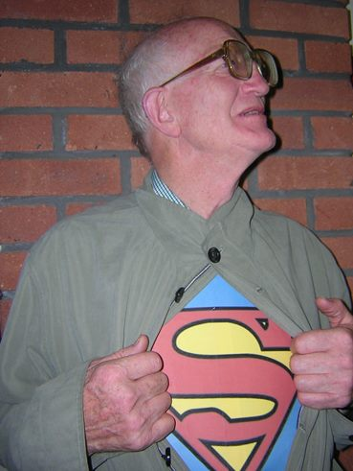
Growing older does not necessarily mean people become confined to their homes. There are many advantages to being older. Being retired can give people the opportunity to volunteer with causes close to their hearts and an estimated one third of volunteers in Ireland are 65 or older.
More and more, older people are returning to education or travelling parts of the world that they could not visit when they were raising a family or working. While these advantages to ageing are not applicable to all older people in Ireland older people’s desires to remain active and engaged with friends and their community.
At Friends of the Elderly we believe that social inclusion and social contact are vital for everyone’s mental health no matter what your age. This is why the main focus of the organisation is on friendship and the benefits of companionship. Friends of the Elderly are aware that as we age, many factors can influence and affect relationships. Physical health and or mental health may decline and this can lead to feelings of isolation and loneliness. Maintaining social contact with people young and old is a crucial part of feeling like we still belong to society.

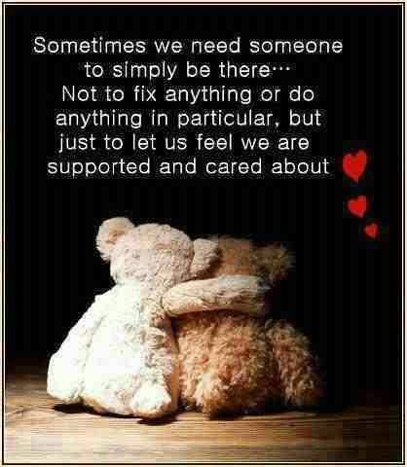

Facts about ageing

- 11.4% of the population in 2011 is aged 65 and over and the number of those aged 85 and over is expected to rise by 44% in the next 10 years.

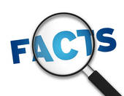
- The CSO predicts that by 2046 the number of people in Ireland 65 years of age or old could be in excess of 1.4m.

- 44% of those 85 and over live alone (CSO Census 2011)

- Prevalence of disability rises with age with less than 10% in those between 50 - 64 years old to nearly 30% in those over 75 years old.

- Loneliness can decrease life expectancy by 10 years and in Ireland 6% of Older Women and 7% of Older Men report to be socially isolated
- One in three over 65s live on their own
- According to the organisation Age Friendly Ireland, one third of those aged over 65 has reported feeling lonely
- Some studies have shown that older people who experience high levels of isolation are almost twice as likely to die within six years compared to those who feel engaged in relationships and the community
- Loneliness has been shown to have links with mental and physical health issues including depression, a higher risk of dementia, cardiovascular disease and reduced immune system response
- Our population is growing by 20,000 additional older people every year. By 2036 it's estimated that 20pc of the population will be aged 65 and older
- It's estimated that, on average, those aged 80 plus spend 80pc of their time in the home
- One study suggests that loneliness may actually be contagious with results indicating that people close to someone experiencing loneliness were 52-percent more likely to become lonely as well.
- A recent study in the UK found that two fifths of older people said that the television was their main source of company
Loneliness definition - Loneliness is the feeling of social disconnectedness in which a person wishes he or she had better social relationships.
Social or physical isolation (which is measured by things like numbers of friends, frequency of contact with friends and family, or distance from local amenities) and loneliness, which is measured only by asking people how they actually feel.
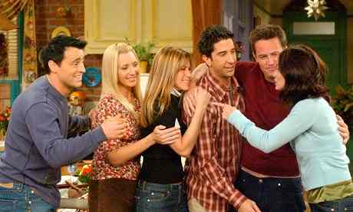
A person can be isolated yet not feel lonely, and conversely, we can still feel lonely in the midst of a crowd. Isolation can sometimes be glorious, but loneliness is never any fun. This said, social isolation is one of the strongest predictors of loneliness that we know.
Friends Wanted

social connections – friends, family, neighbours or colleagues – improve our odds of survival by 50 percent. Here is how low social interaction compares to more well-known risk factors:

- Equivalent to smoking 15 cigarettes a day
- Equivalent to being an alcoholic
- More harmful than not exercising
- Twice as harmful as obesity

Ageing happens to us all
In this section we examine student’s attitude to ageing and the myths and stereotypes which surround the ageing process.

“I thought it must be desperate to be old. To wake up in the morning and remember that you were ancient - and so behave that way. I thought old people were full of aches and pains and horrible illnesses.” Maeve Binchy
“I believed that old people never laughed. I thought they sighed a lot and groaned. They walked with sticks, and they didn't like children on bicycles or roller skates... or with big dogs.” Maeve Binchy
As people age many changes occur. If you look at a picture of yourself in primary school and look in the mirror now, have you changed? Off course you have you have aged.

What does it mean to be old? (Investigation of stereotyping)

Group Discussion

Guiding Questions…..

• What characteristics do we generally connect to something “old”?
• Do these same characteristics apply to all things? to all people?
• Are all older adults the same? How might they be different?

Students should be given opportunities to reflect on how they personally view “old,” and through discussion they will list characteristics of things they believe to be “old.”

Student Activity

What do they think?

What three words would you use to describe an older person?

Name three good things about getting old.

Name three bad things about growing old?

Like everything there are good and bad things about growing old and ageing. What are the good and bad things about being a teenager?

Activity on Stereotyping (Click onto interactive link)
Use worksheet to facilitate discussion.

"All old people are the same" is a stereotype. A stereotype is a statement or belief about a group of people that is thought to be true for the entire group. Another example of a stereotype is the statement: "All old people are bad tempered." Just like younger people, some older people are happy, some are not, some are rich, some are poor, some are short, some are tall, some are healthy, some are sick,. We all have similarities as well as differences; that's what makes us individuals.

What is in the News?
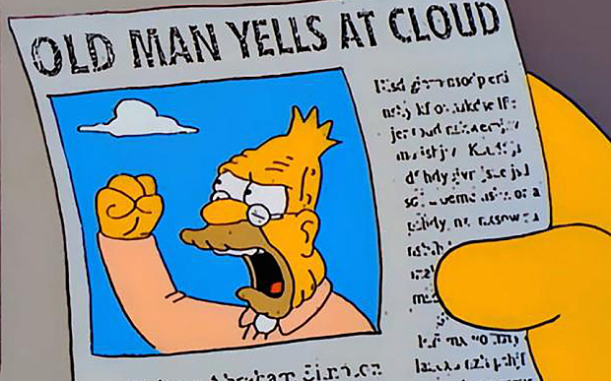
Look at online news article or advertisement that features an older person and answer the questions.
- How does the article or ad show older people?
- Do you think the article or ad is a fair way to show older people?
- What would make it better?

Myths about Aging
Some common myths surrounding old age include: you lose your creativity as you age, older people are always bad humoured, all older people are rigid in their thinking, dementia is inevitable as we get old, all older people are depressed.
Ageism
Ageism makes judgments about the actions, character and desires of people based on their age. There is also a sense that old age is inferior to youth.

Ageism has developed over many years as our society as a whole has put a greater value on youth than on ageing. Television, movies and the media tend to strengthen the idea that young is “good” and old is “bad’’. Our older population is growing rapidly in Ireland. As the numbers increase, so will older people’s power and influence over politics, society and economics

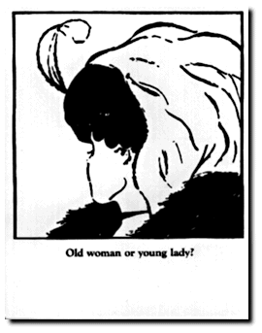
Normal ageing process
Ageing is a process of growth. As we grow older our skin changes and wrinkles can appear. Our hair my thin and turn grey in colour. Our eyesight my start to fail and glasses may be needed to help see the things which we probably took for granted when you were younger such as reading a menu or checking a bus timetable
We may have to turn up the television very loud in order to hear it and this can become annoying for those around with no hearing issues. Ageing bones may become weak due to osteoporosis or the loss of calcium and they can fracture easily. Older people can be sensitive to temperature change because of circulation problems. Generally their weight decreases due to muscle loss and this can affect how a person functions. This ageing process is unavoidable but it can be slowed down by eating healthy and keeping physically and mentally active.

Most people age well and remain independent in their later years. It is only when a major health event occurs such as stroke, heart attack or dementia that people of any age become more dependent.
Ageing is an inevitable part of life and if we are fortunate, old age will come to us all. Exercising and healthy eating can slow the process but it cannot halt the ageing process.

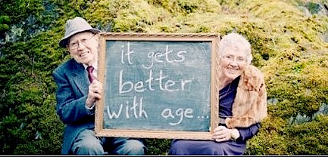

Review Seniors are Cool (on Youtube)
(Time required: 45 mins)
Students are given an opportunity to reflect on their previously held beliefs about older people.
Activity: Discussion
Divide the class in to three groups and ask them to discuss one of the following questions for 2 minutes and then nominate a spokesperson to share the group’s answers.
- What motivates older people to get involved in new activities for the first time? (like the challenge, want to learn)
- Why do older people want to keep doing the same activities they did when they were young? (they have more time now, like doing it)
- Do you know or seen any older person who is doing something cool?

Human Rights and Responsibilities
Time required: 45 Mins
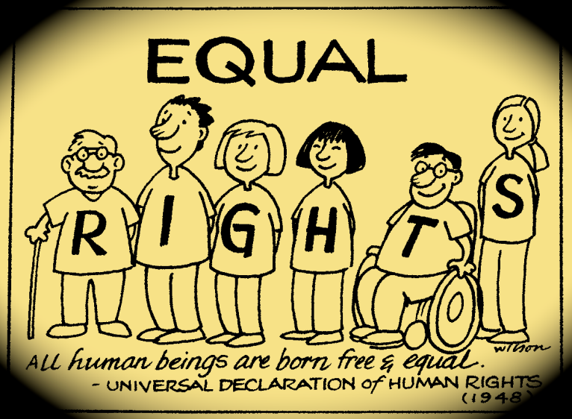
Students will review what basic rights all human beings have and will consider how there are some rights that are specific to certain generations.
Introduce the topic of Human Rights

Activity 1: Group Discussion

Divide the class into groups and ask them to record as many words or phrases that would define human rights. Then ask them to now group them on a Venn diagram the

Rights of the Younger Person

Rights of the Older Person
Shared Rights
Reflect on the importance of human rights and the differences in the human rights of different generations.
Activity 2:

Introduce the idea of rights and responsibilities and how people must take personal responsibility before they can contribute to society
Think of rights in school and what the student’s responsibly are:
Right to: | Responsibility to:
Learn | Listen to instruction and learn respectfully

Ask the students to list other rights and responsibilities being a student.
Now introduce the ideas of responsibilities in society:
Right to: | Responsibility to:
Own a pet | Get a licence, vaccinations, control

Divide the students into groups:
Have student draw two tables and write down personal and social rights and responsibilities and in particular thinking of the rights of older people. (Older people have right to healthcare we have a responsibility both personally and socially to ensure that they can access health services.)
Activity 2: Group Discussion
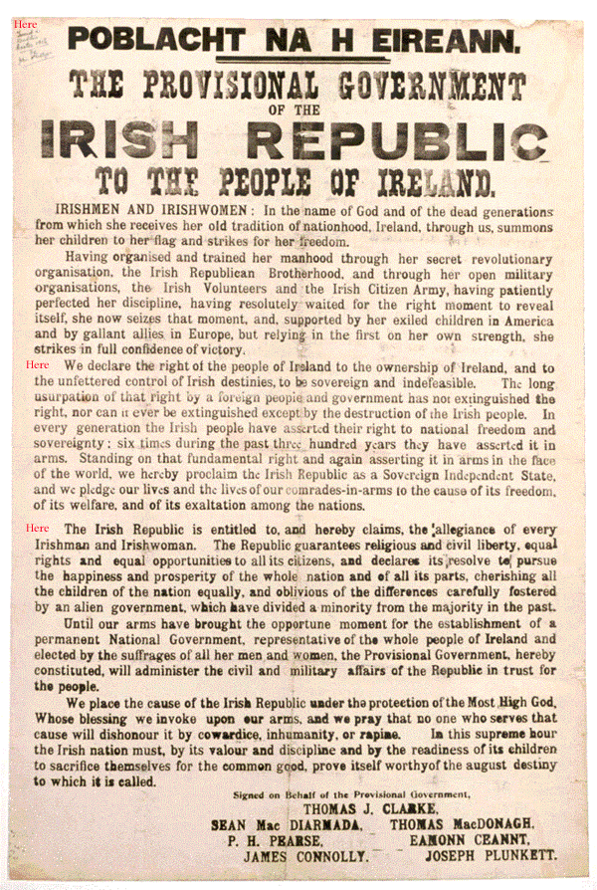
Have each group draw up a Declaration stating what they will do to ensure that the rights of all are recognised in their community.
e.g. “Our group declares that we will make sure everyone and in particular older people will be treated respectfully.”
Each student signs the declaration and it is shared and displayed on the way into class.

Ageing Sensitivity Training

Guide to teaching Aging Sensitivity Training
Younger people often have difficulty understanding what the normal sensory losses and changes older adult’s experience.

To overcome this experiential problem, this classroom assignment, the ageing simulation exercise engages students as active participants in their learning.
Students "experience" first-hand some of the many aches and pains as well as sensory losses commonly associated with the ageing process.

Set up six learning stations for students to visit. Assign a leader to each table to give instruction. Ideally, you should have a leader at each station to discuss their reactions as they experience each simulation/barrier of ageing.
Supply Kit Teacher or Presenter will need

The "Immediate Aging Kit" includes:
- yellow- or amber-coloured sunglasses or clear glasses
- petroleum jelly
- gardening gloves
- transparent tape
- coin purse with play money (about 10 singles and 41 cents in small change)
- empty medicine bottle (please ask a parent to supply you with an empty medicine bottle)
- small colored buttons (3 to 4 buttons) for medicine bottle

Other Supplies
- paper or poster board
- old magazines and newspapers
- glue
- scissors
- markers, crayons, or coloured pencils
- telephone book
- intergenerational storybooks
- cotton or disposable ear plugs
- radio
- television
Gather the students together and discuss their reactions to the “challenges” that may complicate the lives of elderly people. Discuss how they should react when they observe someone having difficulty.
Raise awareness of some student behaviour that will improve the experience of meeting with their ‘’older friend’’.

Speak in a clear voice (not shouting.)
Be respectful of your older friends limitations
Move slowly as a boisterous student may be a little frightening

Station 1. Changes in Vision
As we grow old, our eyes change, it becomes difficult to tell colours apart, especially greens and blues. This happens because the lens of the eye becomes yellow and less flexible.
It becomes harder for the eyes to adjust to changes in light. Older people may have to take time to adjust to the light in a room after coming in from outside.
If there isn't enough light, it is very easy for an older person to trip over or run into things they cannot see. It is sometimes difficult for older people to judge distances.
Older persons may not recognise objects until they are quite close to them. They may not have enough time to move out of the way before they trip over the object or run into it.

Project Skill
- Experiencing what it is like to have vision loss.

Materials Needed and What to Do
Put petroleum jelly on sunglasses or yellow- or amber-coloured glasses and try to read a newspaper or the schools website (to simulate failing vision)

Have a task for the students to do.
Looking Back...
- Were any of these activities difficult for you? Why?
- How can understanding about vision problems help you relate to older people?
Overview:
As adults get older, changes in their vision make daily tasks more difficult. 95% of individuals over age 70 develop some sort of vision loss. There are many reasons for loss of vision or reduced vision:
Cataracts – clouding of the pupil causing vision loss.
Macular Degeneration – the central vision deteriorates.
Glaucoma – damage of optic nerve which can lead to blindness.
Decrease in peripheral vision.
Sensitivity to light as the eye muscles loose strength.
Fewer tears produced with age causing dry eyes/burning/ stinging.
Development of spots and floaters in the eye.
Vision loss from detachment of the retina.
Materials:
Glasses coated with a thin layer of Vaseline(makes it hard to see)
Prescription bottles/medicine (to read the label)
Newspaper or Book
Phone
Form or instructions
Activity:
Put the glasses on (that have been coated with Vaseline).
Attempt to do everyday tasks such:
o Reading a prescription bottle/medicine. o Reading a newspaper or book.
o Filling out a form.
o Making a phone call.

Station 2. Hearing Changes
Changes in hearing can cause difficulty for older people. Talking may sound muffled because it is more difficult to hear high-pitched consonant sounds like th, sh, s, f, and p, to name a few.
Vowel sounds (a,e,i,o,u) are low-pitched sounds, so they are easier to hear.
This type of hearing loss makes it difficult to:
- hear in noisy places, such as a restaurant or mall,
- use a telephone,
- watch television with others because the volume may be too high for people who can hear normally.
Shouting at a person who is hearing-impaired only makes problems worse. Shouting raises the pitch of your voice, which makes it even harder to hear what you are saying.

Project Skill
- Experiencing hearing loss

Materials Needed and What to Do
Put cotton balls in ears (to simulate deafness) and write down 10 words said to you by your friend in a high pitched voice and once again in a low pitched voice.
Looking Back...
- How did you feel during this activity?
- How does this activity help you relate to older people in real-life situations?
- How can you use what you learned in this activity when you are talking to an older person?

Overview:
As we grow older, our hearing gets weaker. This is due to a number of reasons such as:
Ear wax builds up.
Damage to the ear drum.
Fluid in the ears.
Weakened nerves in the inner ear.
Materials:
Cotton balls
Ear muffs or head phones
Activity:
Put cotton balls in your ears and/or ear muffs/head phones on
Have a friend whisper, talk or yell at different distances to see how well you
can/cannot hear.

Station 3. Changes in Touch and Dexterity
As people get older, their fingers, feet and knees can begin to feel stiff. Their sense of touch may also be affected, which makes it more difficult to detect extremes in temperature, and to feel vibration, pressure, and even pain.
As muscles grow smaller and weaker, it becomes more difficult to lift shopping or do housework. If muscles are not used, they become weaker.
Older people who have problems with touch and dexterity may be more likely to:
- cut themselves and not notice the pain,
- burn themselves while cooking or ironing or in a hot bath water,
- have trouble getting out of a low sofa or chair, and
- fall and hurt themselves.

Project Skill
- Experiencing difficulties with touch and dexterity

Materials Needed and What to Do
- Try to open a small box of or bottle while wearing rubber gloves with cotton in the fingertips (to simulate the clumsiness of arthritis).
- Walk with beans in shoes (to simulate the discomfort of walking).
Looking Back...
How did you feel during these activities?

Were the routine tasks difficult for you? Explain your feelings.

How do these activities help you relate to older people in real life situations?

How can you use what you learned in this activity?
Activity Stiff Fingers
Overview:
Arthritis causes seniors to experience stiffness and pain in their joints, often making it challenging to perform everyday activities. This activity will help simulate stiff joints, arthritis and a reduced sense of touch.
Materials:
Tape or Band-Aids
Heavy work gloves, winter gloves or mittens
A shirt or jacket with buttons and/or a zipper
Shoes with laces
Paper and pen/pencil
Change purse with coins/bills
Activity:
Put Band-Aids, or wrap tape, around the finger joints to simulate stiff joints.
Place gloves on each hand to experience a reduced sense of touch as well
as stiff joints.
Try some daily tasks to see how challenging they become: o Put on a shirt or jacket and button/unbutton it.
o Put on a piece of clothing with a zipper and zip it. o Tie your shoes.
- Take money out of a change purse. o Write your name.
Activity 3 - Loss of Balance/Mobility
Overview:
Seniors may experience changes in balance, mobility and dizziness. Those changes can make getting around and performing everyday activities a challenge. Foot pain from bunions and corns can also make getting around and doing simple tasks even more difficult. This activity will simulate those changes.
Materials:
Dried beans or popcorn kernels
Cane or walker
2 bags of groceries
Umbrella
Activity:
Put dried beans or popcorn kernels in your shoes to simulate foot pain.
Put your shoes on the opposite feet to simulate the loss of balance and
mobility.
While using a cane or walker, pick up and carry 2 bags of groceries – you’ll
see it is difficult.
For a real challenge – pretend that it is raining and hold an umbrella while
carrying the groceries and using the cane.

Changes in Taste and Smell
A sense of smell helps you taste food. Changes in the senses can make eating less enjoyable for older people. Food seems to have very little flavour. A diminished sense of smell also poses safety problems for older adults. They may not smell escaping gas, smoke or smell when food is off It can be especially dangerous for a person whose sense of smell is impaired.
Project Skill
Experiencing changes in the senses of taste and smell
Materials Needed
Activity sheet for each participant
pens or pencils
amber-coloured sunglasses
two mints different flavours that are similar in colour
Please remember to leave your glasses and gloves on!

What To Do
To experience the frustration of losing your senses of taste and smell, try the following tasks. Put on your glasses and gloves again, and you will use other items in your "immediate ageing kit" as well.

Task A
Take out crackers and jelly.
Place a small amount of jelly on the cracker.
Hold your nose and take a bite of the cracker.
Try to guess the flavour of the jelly. What is the flavour?
Task B
Take out a piece if chewing gum or a mint.
Unwrap the piece of chewing gum or the mint.
Hold you nose, and place the gum or mint in your mouth.
Try to guess the flavor of the gum or mint. What is the flavor?
Looking Back...
How did you feel during these activities?

Were the activities difficult for you? Explain your feelings.

How do these activities help you relate to older people in real life situations?

How can you use what you learned in this activity in your own life?

Walk with a walker while blindfolded (to experience the difficulty)
Push someone in a wheelchair (to experience the barriers)

Discuss with the class how their views on old age and the ageing process may have changed having thought about the aging process and what attitudinal changes students may make to prevent ageist attitudes or prejudices from colouring their view of the older people in their communities.

Most people age well
Older people mainly lead active and healthy lives. You may recognise some famous older celebrities who are still very active within their respective fields. Can you name some older celebrities and discuss what perceptions of ageing are portrayed by the mass media? Perhaps look through magazine advertisements to see if ageing is shown in a positive or negative light. Discuss your findings amongst the class.

Older people can lead active and healthy lives and remain independent in their later years. It is only when a major health event such as a stroke or the loss of memory that they lose their independence.

Write the names of four famous older celebrities in the space below and say why you think they have aged well.

Celebrity Why you think they aged well

_____________________ ____________________________

_____________________ ____________________________

_____________________ ____________________________

_____________________ ____________________________

Age and age attitude
Age and attitude are different; many older people say they don’t feel their age or they may say to you “act your age”. The age we are is usually different for what we feel inside.
Ask four people their age and how old do they feel, most time they differ.

Age of Person How old they feel

___________________ __________________________
___________________ __________________________
___________________ __________________________
___________________ __________________________

Further Resources
Spotlight on Stereotyping- http://www.ubuntu.ie/media/Spotlight-on-Stereotyping.pdf
Myths and Stereotypes of Aging - http://www.oregon.gov/dhs/apd-dd-training/EQC%20Training%20Documents/Myths%20and%20Stereotypes%20of%20Aging.pdf
Age Actions Intergenerational Tool Kit - http://www.youth.ie/sites/youth.ie/files/Chapter_13_Working_across_the_generations_0.pdf
Seniors are cool
http://www.gov.mb.ca/shas/seniors_are_cool/seniors_are_cool.html
Beth Johnson Foundation Guide to International Practise - http://www.centreforip.org.uk/res/documents/page/BJFGuidetoIPV2%20%2028%20Mar%202011.pdf

Loneliness and social isolation can affect everyone but older people are particularly vulnerable after the loss of friends and family, reduced mobility or limited income

If you are opening your school to older people please consider their limitations in mobility, hearing or vision.
- Involve colleagues; it will enhance the quality of the experience if everyone is involved.
- Ensure walkways are clutter free and wide enough for walkers, sticks, and wheelchairs
- Control sources of background noise before the activity commences
- Use large print on signs

Quote
“People with passion can change the world.” Steve Jobs

MYTHS AND STEREOTYPES OF AGING
What do you know about aging? Circle either “true” or “false” for each of the following questions:

1. In general all older people are alike. True False
2. The majority of older people have dementia. True False
3. Older people have no more worries once they retire and start enjoying life. True False
4. Most older people are set in their own ways and are unable to change. True False
5. Older people are unproductive and uncreative; they cannot work as effectively as younger people. True False
6. Older people are slow to learn, less intelligent and more forgetful. True False
7. Older people are bad tempered and difficult to get along with. True False
8. The majority of older people are socially isolated and lonely.
True False
  - Older people become more religious as they age.
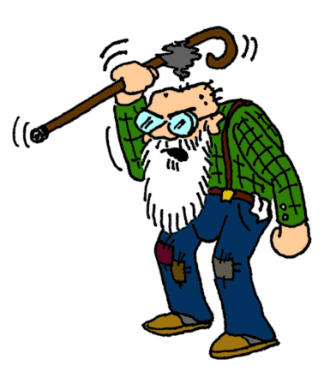
True False

