
Internship Application Form
Personal Details:
Start Date Internship: End Date Internship:
Name: Surname:
Address:

Home phone: Work phone:
Mobile phone: E-mail:

Date of birth: Occupation:
Do you have any requirements e.g. mobility we should know about?

Special Skills: Please share any special skill/talents that you would like to share in your volunteer work (i.e. Music, Gardening, Painting, Art, etc.):

Emergency Contact Information:
Name: Surname:
Emergency Contact Phone: Relationship
References:
Please provide us with the name of a person over the age of 18, not related or in a relationship with you, who can provide a reference. It can be a teacher, personal acquaintance, former/current colleague, employer or anyone else that would be able to comment on your suitability for a volunteer/intern role with Friends of the Elderly.

Referee
Full name
Position/ Company
Address
Phone number
Email

How did you hear about Friends of the Elderly?
Have you volunteered before?

Areas of Interest

☐ Administration: Data entry, File management, Email correspondence etc.

☐ Friendly Call Campaign: A friendly chat on the phone can make all the difference to our older members

☐ Social Club Hosting & Support: Every Wednesday from 2-4 we host our social club at 25 Bolton Street where our elderly members meet new friends at our various social activities.

☐ Charity shop: Friends of the Elderly run a charity shop at 25 Bolton Street.

Our office hours are 9-5pm Monday to Friday with one hour for lunch. Please advise if the intern is not available at these time e.g. because they are attending school etc. :

In accordance with the 1998 & 2003 Data Protection Acts, I agree that Friends of the Elderly may hold and use personal information about me for volunteering reasons and to keep in touch with me. This information, including that contained in this form, can be stored on both manual and/or computer files. It will be held securely and only accessed by authorised persons.

Organisation managing your internship
Name:
Contact Person:
Phone number:
E-mail:

Signature Applicant: Date of application:

________________________________ ______________________
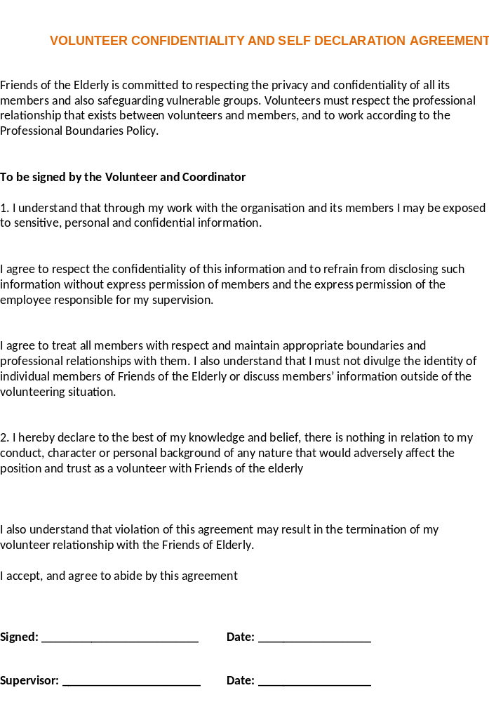

Code of Conduct for Volunteers

The purpose of the Code of Conduct for Volunteers is to set out standards of behaviour expected from volunteers of Friends of the Elderly Ireland (Little Brothers) Limited (‘FOTE’). All volunteers should ensure that they have read and comply with this Code of Conduct.
Volunteers should maintain the highest standards of behaviour in the performance of their duties by:
- Fulfilling their role as outlined in their written volunteer role description to a satisfactory standard;
- Performing their volunteer role to the best of their ability in a safe, efficient and competent way;
- Following the charity’s policies and procedures as well as any instructions or directions reasonably given to them;
- Acting honestly, responsibly and with integrity;
- Treating others with fairness, equality, dignity and respect;
- Raising concerns about possible wrongdoing witnessed by the volunteer in the course of the volunteer’s role with FOTE with the coordinator and the Manager;
- Meeting time and task commitments and providing sufficient notice when they will not be available so that alternative arrangements can be made;
- Acting in a way that is in line with the purpose and values of the charity and that enhances the work of the charity;
- Communicating respectfully and honestly at all times;
- Observing safety procedures, including any obligations concerning the safety, health and welfare of other people in line with training provided to volunteers;
- Reporting any health and safety concerns;
- Directing any questions regarding FOTE’s policies, procedures, support or supervision to the volunteer’s supervisor;
- Addressing any issues or difficulties about any aspect of their role or how they are managed in line with FOTE’s grievance procedures;
- Declaring any interests that may conflict with their role or the work of the charity (e.g. business interests or employment). If any doubt arises as to what constitutes a conflict of interest, volunteers may seek guidance from the Coordinator or the Manager;
- Keeping confidential matters confidential;
- Exercising caution and care with any documents, material or devices, containing confidential information and at the end of their involvement with FOTE returning any such documents, material in their possession;
- Seeking authorisation before communicating externally on behalf of FOTE
- Maintaining an appropriate standard of dress and personal hygiene;
- Disclosing the fact that they have been charged with, or convicted of a criminal offence by prosecuting authorities (or given the benefit of the Probation of Offenders Act 1907 as amended) to the Manager. For the avoidance of doubt, volunteers are not required to disclose the fact or details of ‘spent convictions’ under the Criminal Justice (Spent Convictions and Certain Disclosures) Act 2016 (as amended) to FOTE.

Volunteers are expected NOT to:
- Bring the charity into disrepute (including through the use of email, social media and other internet sites, engaging with media etc.);
- Seek or accept any gifts, rewards, benefits or hospitality in the course of their role;
- Engage in any activity that may cause physical or mental harm or distress to another person (such as verbal abuse, physical abuse, assault, bullying, or discrimination or harassment on the grounds of gender, civil status, family status, sexual orientation, religion, age, disability, race or membership of the Traveller community);
- Be affected by alcohol, drugs, or medication which will affect their abilities to carry out their duties and responsibilities while volunteering;
- Provide a false or misleading statement, declaration, document, record or claim in respect of FOTE, its volunteers, employees or charity trustees;
- Engage in any activity that may damage property;
- Take unauthorised possession of property that does not belong to them.
- Engage in illegal activity while carrying out their role.
- Improperly disclose, during or after their involvement with FOTE ends, confidential information gained in the course of their role with FOTE.
Where a volunteer is found to be in breach of the standards outlined in this Code of Conduct or any of FOTE’s other policies and procedures this may result in the volunteer’s position being terminated. Volunteers acknowledge that no employment relationship is created in the context of their role with FOTE.
The board of Directors will review the Code of Conduct for Volunteers at 3-year intervals or as appropriate. The Manager is responsible for ensuring that this policy is implemented effectively. All other staff and volunteers, including charity trustees, are expected to facilitate this process.

I have read, I understand, and I accept the conditions set out in this Code of Practice.

Signed . . . . . . . . . . . . . . . . . . . . . . . . . . . . . . . . . . .

Volunteer Name . . . . . . . . . . . . . . . . . . . . . . . . . . . . . . . . . . .

Date . . . . . . . . . . . . . . . . . . . . . . . . . . . . . . . . . . . .

